THE EXHIBITION OF PEOPLE’S TECHNOLOGY
MODERN ART MUSEUM ANNEX
SKEPPSHOLMEN
STOCKHOLM
AUGUST 1972

SOME REMINISCENCES BY PETER HARPER (WHO IS BRITISH) SLIGHTLY AT RANDOM

I had many friends in Sweden, having been visiting since 1967.

The UN Conference on the Human Environment (UNCHE) was the first major recognition of the significance of the global environment, and a Great Event. Naturally every young environmentalist and her dog wanted to be there, and I was no exception. I took part in a series of meetings in Scandinavia earlier in 1972 to plan various fringe activities.

My friend Björn Eriksson, an engineer, knew Pär Stolpe, an official of the Modern Art Museum in Stockholm, who was keen to present something relevant to the conference. He made available an Annex building on the island of Skeppsholmen, walking distance from the city centre. Björn and I conceived the idea of an exhibition of ‘alternative technology’, although in Swedish it was called ‘För en Teknik i Folkets Tjänst’ which translates as ‘Towards a technology to serve the people’.

In the months before, Björn and I drew up plans for what we would like to display, and started to collect materials. We had no money or institutional resources to draw on, so we ‘begged, borrowed and stole’, leaning on friends and acquaintances and our own research and imaginations. Even so, the exhibition was a bit thin when we started, and we decided it just had to be a ‘work in progress’ that would gradually bootstrap itself into something tangible by the end. This was very much in the improvisatory spirit of the subject-matter.

I arrived in Stockholm with my colleague Chris Ryan, and our partners Lyn Gambles and Barbara Hammond. Together with Björn, the architect Varis Bokalders and many other local contributors, we started to assemble pieces of equipment, models, and explanatory texts. People would drop in from absolutely anywhere and spend a few days with us. I remember Godfrey Boyle arrived with some members of the Undercurrents team, and set up floating inflatables around the island, allowing us to ‘walk on water’ (see pic). Richard Coon drove from London on his propane-powered motobike.

The eventual layout was something like the plan shown below, with ‘exhibits’ around the outside and space in the middle for discussions, chatting and for visitors to make their own contributions. There was a landscape model of a traditional village that you could visit at full scale just across the bay in Skansen. Unfortunately, very few photographs have come to light, except some embarrassing images of myself with the ubiquitous and infinitely hirsute ‘1970 eco-face’.
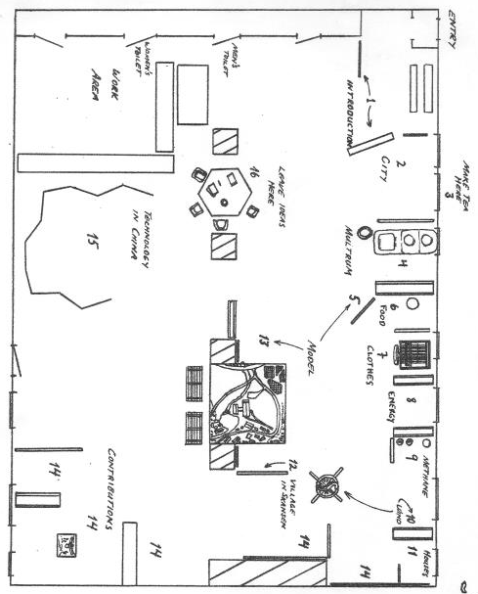

We were there all the time of course, and visitors could see everything being assembled, written, argued over, pasted up and (often) hastily modified. But it meant that we got to engage with them, and often enough they stayed to help.

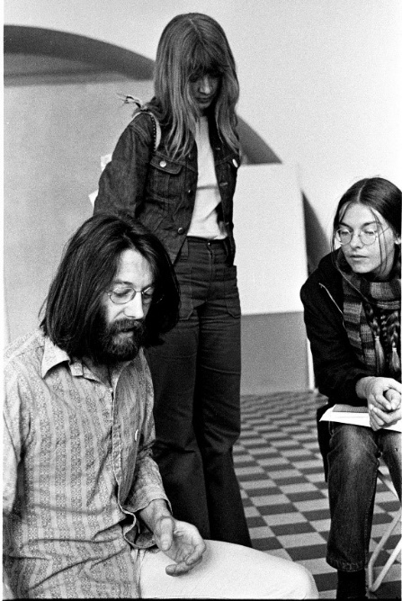
The image at right tells something of the place and the process. Yes, that is the younger me with the 1970 eco-face. I am obviously showing something to two young women, who perhaps just dropped in to see what was going on. The floor is tiled and the walls are bare, but there are semicircular alcoves. There is a blank display board in the background. It was severe but functional and we liked being there.

Often we would work till very late, then just curl up in sleeping bags on the floor, to start again the next morning. It was definitely a young people’s affair!

It led to the setting up of the permanent UN Environment Programme (UNEP) in Nairobi, and was followed by further important conferences in Rio 1992 (when the UNFCCC and the Convention on Biodiversity were signed by almost all major governments) and Johannesburg 2002.
Chris Ryan was a physicist who moved into design and town planning, eventually becoming Professor of Design at the University of Melbourne, with visiting posts in Sweden, Italy and The Netherlands. He was a founder of the alternative technology demonstration centre ‘Ceres’ in Melbourne in 1975.
Varis became a distinguished architect and the author of many books including the magisterial Byggekologi, translated into English as The Whole Building Handbook, Taylor and Francis 2010.
Godfrey Boyle founded the alternative science magazine Undercurrents in 1971, and co-edited Radical Technology (Random House, 1976). He later becoming Professor of Alternative Energy at the UK’s Open University. Sadly, he died in July 2019.

