PROBING THE LIMITS OF LOCAL PROVISION
Taking issue with notions of localism and self-sufficiency
Peter Harper January 2015

In the ‘very olden days’, most needs was satisfied locally. Supply and quality were often erratic. There was however vigorous trade in goods and materials from outside the immediate area. Some of these were simply luxuries (say, jewels, wine, sugar), some basic (salt, metal pots, knives, axes), but many were preferred because they were cheaper and/or performed better than the equivalent local items, for example candles, dye minerals, certain cloths, special tools. Some were ‘intermediate goods’ used to improve local productivity, such as metals and tools and raw materials such as lye, vinegar.

The ‘imported’ materials were themselves produced in an artisanal fashion, obtaining their raw materials either in their own locality or (again) from outside the area.

It was all rather expensive in terms of how much time/labour it took to create an item or to generate the money or barter-power to buy it. In other words, by modern standards, productivity was extremely low.

This started to change with the rise of specialised workshops, as immortalised by Adam Smith, and later the factory system with steadily increasing artificial energy inputs. The factories themselves rapidly raised productivity, generating goods that were far cheaper than their artisanal equivalent, and often superior in quality as well.

In some respects, this is what we were all waiting for: the ability to get more for less, in principle releasing everyone from obligatory drudgery. We liked it. Economies of scale made the factories fewer but bigger, and gradually most things we bought were sourced nationally or internationally and moved around by relatively cheap transport. By historical standards they were unbelievably cheap. There was still some local production, but virtually all raw materials and intermediate goods were supplied nationally.
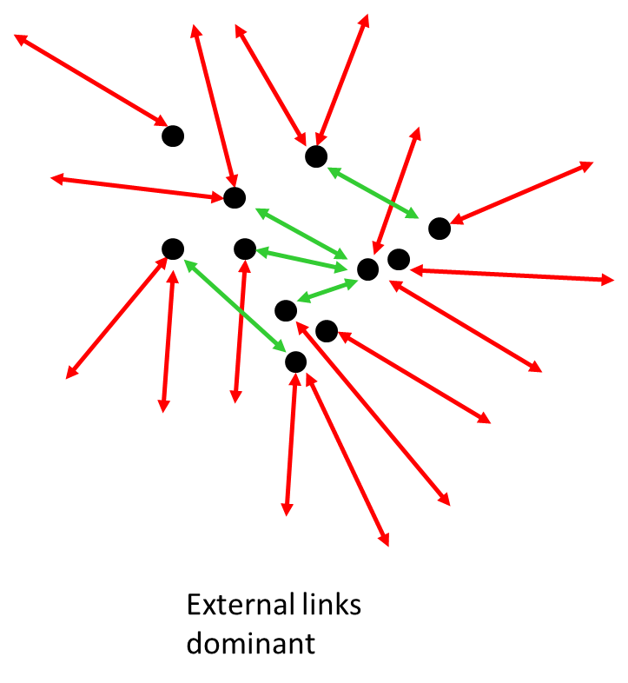
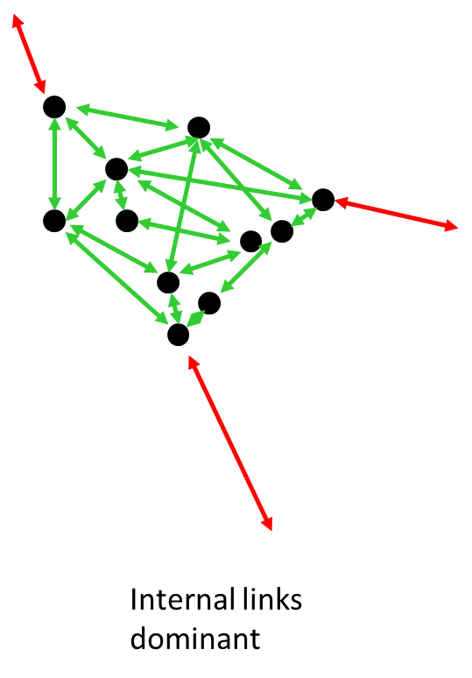
The shift can be illustrated by the following images:

The dots represent economic entities such as households, enterprises, public institutions. The arrows show patterns of provision and general traffic, green for local, red for external. Pretty obvious really.

Now, there are many reasons to feel that this process might have gone too far, and many of us are looking for a better balance, or even to go back to the pattern on the left. So let’s explore the matter: how far can we go?

It’s worth remarking at the outset that many have achieved an illusion of the left-hand pattern through being wealthy enough to be able to purchase craft items and locally-generated goods. Their wealth has of course come from the highly-productive industrial system. Gandhi sometimes used to joke “My friends tell me it costs them a fortune to keep me in poverty”, and it was probably true. My impression is that a series of ‘Potemkin Villages’ were created for him to live in, producing a fairytale illusion of noble simplicity that lives on in the spinning wheel gracing India’s national flag.

Presumably, discerning critics of the present dispensation are aiming at a more fundamental transformation. Personally I have been most impressed and influenced by the Australian thinker and practitioner David Holmgren, who argues for a substantial restoration of ‘the household economy’. How far can this be taken? To answer this question I have constructed the table below.

There are four columns. The first lists a sample of goods and services that are currently provided from national or international industrial sources, using further chains of industrial products to supply them.

The second column is used for comments. The third column lists goods and services provided by local suppliers that depend critically on supplies of industrial goods, tools and materials. The fourth column lists items that could ‘genuinely’ be provided locally, with minimal dependence on the industrial system.

TOTALLY INDUSTRIAL | Comments | LOCAL PROVISION WITH INDUSTRIAL FEEDSTOCK | GENUINE LOCAL PROVISION
Drinking water | At ~£2/m3, very cheap | Rainwater collection with tanks & filtration | Still some wells, roof collection
Waste water treatment | Same | Septic tanks/leachfield; reed beds | Privy with greywater soakaway
Electricity | Cheap by historical standards ~1% of typical household budget | Local electricity generation, PV; small wind highly inefficient and expensive; off-grid with batteries | Electricity-free modern home unlikely but conceivable; common in the 50s (I lived in one)
Heating fuels | Very cheap ~5% of average household budget in UK | Wood, various degrees of technical sophistication;  SWH; PV-powered heat pumps | Local wood on open fire; several ha required to provide modern standards; perhaps just cooking is possible; charcoal
Vehicles |  | Carts, bicycles, bike shop, car clubs | Horses/donkeys, wagons, walking
Vehicle fuels | Virtually all fossil.  EVs using batteries | Could produce vegetable oils from farms; woodgas; charge vehicles with PV etc
Buses |  | Bus services often run locally | Rickshaw? Walking
Trains |  | Short local lines
Flying |  | Private aircraft
Ferries |  | Private boats/yachts | Wooden boats, coracle
Roads |  | Roman metalled roads; local unsurfaced roads | ‘The old straight track’
International shipping |  | Small-boat trips across the North Sea and channel; like Vikings? | You could recreate Viking longboats, or St Brendan’s seagoing coracles
Road freight |  | The butcher’s van. Local trucks, pantechnicons | Horse and cart.  Tinkers
Motive power | Usually provided by electric motors | Electric motors run from off-grid power;  Steam and Stirling engines | Many human/animal-powered systems; wind- and water-mills
Industrial commodities, machine tools (‘intermediate goods’) | A vast category, possibly larger than all consumer goods | Locally-made tools; the village blacksmith; fine ceramics | Pole-lathe, wood, clay, earth, lime kilning
Rubber, plastics, membranes | Hard to manage without! |  | Leather equivalents
Glass, windows |  | Local glazier | Coarse glass items, bottles, from local sand
Building materials, building | Tens of thousands of materials and products | Local builders, builders merchants | shakes, stone tiles, clayware, thatch, rammed earth
Domestic electrical goods | Washing machine  Fridge/freezer  Cookers | Repairs, ham radio, battery charging, | Wash by hand, no refrigeration, cooking on open fire
Lighting | Incandescent→CFL→  LED  Very low cost and energy per lumen | Oil lamp with mantle, paraffin wax candles (very expensive and inefficient per lumen) | Oil lamp, tallow candle (even worse)
Electronic devices, computers, calculators |  | Local repair and refurb | Abacus, slide rule for calculations?
Communication: smart phones, satellite links |  | Local telephone exchanges; snail mail | Written messages delivered by hand
Textiles, Clothing, footwear |  | Local tailors, seamstresses, sewing machines; fashion items; cobblers | Some hand-spun/knitted/woven textiles; natural dyes;  New clothes from industrial textiles. Leather boots
Paper |  | Small production runs, craft-style papers | Vellum, slate-boards, wax tablets
Cookware | Stainless steel. Advanced glass, cast iron, alloy, non-stick, advanced ceramics | Hand-casting of iron, alloys.  Implements made by blacksmith | Simple ceramics, basic iron pots, spits, treen,  Treadle-lathe, wheel, bellows
Food commodities, retailed foods | Fully processed, packaged, food ~11% of average HH expenditure, much ‘luxurious’ | Local whole food shop: grains,oils, condiments; local abbatoir and butcher; local dairy; CSA arrangements; Bakery, pub, café | Vegetables with self-collected seed; poultry, goats; with enough land, grains and oilseeds; pulse crops. Home baking, brewing
Detergents, soaps, household chemicals | Tens of thousands of products, recently liquid | Local artisans make up special soaps etc | Basic soaps from ash, lard etc
Medicines, hospitals, dentistry | An enormous and complex industry | Local complementary practitioners, midwives | Alternative therapies; Bone-setter, tooth-puller
Tampons, contraceptives |  | Craft-based tampons?
The Education system; Training courses | Institutionalised from ~3 to universities | Schools, vocational training | Local informal schools, learning on the job, apprenticeships
Banks, currency |  | Credit Union | Informal credit and barter, local currency
TV & radio broadcasting |  | Local radio station | Home entertainment, Am Dram, festivals
Books, National newspapers, journals |  | Local papers and leaflets, local printers | Block printing
The Internet | Becoming universal; totally dependent on functioning of integrated modern system | Internet cafes, hotspots | Ignore?

Well perhaps I should leave it to others to try and fill up the right-hand columns, but after trying this exercise I am left with the impression that I personally am completely dependent on the mainstream industrial system and I simply would not survive without it. Neither would I want to. Trying to fill in the fourth column amounts to a reductio ad absurdum of de-industrialisation scenarios. Try it yourself.

The question we asked in the early years of AT is still there: is this industrial way of doing things intrinsically unsustainable? Or are we simply doing it wrong?

Another question: is there a halfway house, or is it either full blown industrialism or total neo-primitivism?

If the economy is ‘too big’, you could perhaps make it smaller in various ways, but probably not by simply rewinding the clock. Basically you could have less of everything, fewer clothes and shoes, fewer TV channels, simpler foods, less higher education, more vocational training, fewer drugs, restricted social services and hospital treatments, lower wages, smaller and cooler houses, fewer and more local holidays, fewer and smaller cars, more car-sharing, biking, walking.

Obviously we have been exploring many of these things. The trick is to find ways of reducing environmental impacts without damaging the ‘quality of life’. In some cases we do sometimes find that ‘less is more’ or there are advantages to simplifying life somewhat. The problem is the System as a whole has its own logic and momentum, and it is hard to see how to amend it, guide it, reform it, while maintaining its essential functionality.

Personally I cannot help being influenced by memories of life in the 40s and 50s (!). The UK GDP was about one third of its present level, and our household income was probably close to the average. Was the ‘tenor of life’ markedly different? It did not seem a frightful grind. Admittedly no car, washing machine, fridge, TV, central heating. But we kept warm (ish), cooked the dinner, went shopping, went to school and work, had holidays, went off to the country at weekends (or the park, or museums), regularly went to the cinema and pantomimes, accommodated guests, had plenty of Christmas and birthday presents, free medical care…etc

All the essentials of ‘modernity’ are already there. As a kid it seemed utterly brilliant, and I’d be entirely happy to be there again. But it was ‘the age of austerity’ and that word hangs over us again today, provoking an involuntary shudder. It means reduced medical and social care, schools and libraries closed, university fees increased, pensions reduced, free travel rescinded, potholes in the roads, less social housing and so on. These appear to be the implications of a slightly reduced GDP. Could we run a 21st century economy on only one third of the throughput?

Like many alternative-minded folk I have experimented with life-style changes that would greatly reduce my ‘footprint’ while having little impact on my quality of life. I shall now list these, but ask the reader, do any of them entail reduced reliance on the effective functioning of the industrial system as a whole? They make it smaller; they don’t render it unnecessary

Lower levels of
Recreational flying
Recreational driving
Indoor temperatures
Housing space
Meat consumption
Furniture, appliances
Processed and frozen foods
Laundry, bathing, showering
Household renovation and refurbs
New durable goods

Levels of these have little bearing on my overall Quality of Life. I simply adjust various arrangements and expectations to fit. But I still want doctors, dentists, wholesome and varied food, cheap electricity, public transport, my laptop, the internet, radio and TV, books, water supply, foul drains, liquid detergents, functioning buildings, windows, tools….and no more than a 40-hour week.

This has considerable bearing on discussions regarding the proportions of people who would prefer to adjust their behaviour relative to those who would prefer to pay more rather than change themselves. It strikes me that nearly all the ‘alternative’ ideas have been around for at least a generation, going back to the 70s. They often grew rapidly at first, giving an impression that they could penetrate the whole of society. But on the whole, they remained limited to the radical/green minority, between 5-15% of the population.

This might remain the case in a rapid decarbonisation transition, where strenuous efforts are made not to force lifestyle changes, but to encourage and enable them if people are willing to embrace them. Under these circumstances we might find a larger minority willing to make substantial lifestyle changes.

It is worth noting however, that even the most extreme ‘downshifters’ remain beneficiaries of a basic industrial infrastructure providing a million and one goods and services very cheaply, even if they enjoy the benefits at one remove. I doubt that, put to the test, anyone would wish it otherwise.

A final conclusion. A planned transition must be based on the basic industrial infrastructure and try not to force people to do things they don’t want to do (at least at first). However, a culturally flexible minority will naturally prefer to change their behaviour, and the transition process should give them every encouragement as being the most rational way to cope. Others might gradually adopt their patterns.

The obvious fly in the ointment here is that another significant minority will define its identity against the lifestyle pattern, and will insist on maintaining the Old High Consumption Ways as far as possible. We should anticipate this, and perhaps try to find satisfying Potemkin-style ways of meeting their tastes. ,

Of course it all took quite a long time, with the property-owing class reluctant to share the spoils, but we are more or less there now, in principle anyway.
Just to give an example, in 1550 a kg of wheat-flour cost a day’s wages; in 2015 it was ~2% of a typical day’s wages. In the same period the cost of lighting decreased about 1000-fold.
For those unfamiliar with this expression, it refers to the creation of bogus idealised villages on the banks of the Volga by Prince Grigory Potemkin in order to reassure Catherine the Great, during her trips down the Volga, that all was well and the peasants happy in her kingdom.
I recall visiting an Arts & Crafts exhibition at the V&A in London, some years ago. The Arts&Crafts movement of the 19th Century was launched to counter the perceived ugliness of mass-produced industrial products, and the items were indeed exquisite. But it was obvious they could only have been afforded by the extremely wealthy of the time, and indeed of today as well. They did not solve the problem of providing essential household items at low cost. The reconciliation of cost and aesthetics was eventually addressed by the Bauhaus and other movements, and today, arguably, by IKEA. Intriguingly, an insightful take on this issue was provided by Frank Hampson’s first Dan Dare adventure in the newly-created Eagle comic of 1950. The story conjures up a race of human-like beings on Venus, the Therons, whose industrial base is entirely automated in concentrated production centres run by robotic processes. This frees them to live ‘simple’ Gandhian lives pursuing the arts of civility in the countryside, much as many (on Earth) aspire to today.
Female friends have noted wryly ‘Ah, that’s because you were a boy: it wasn’t so much fun for us’. And what about the grown-ups?
An example might be smallish, lightweight cars with souped-up engines and no silencers. They could accelerate very fast and move at a colossal speed, making a great din. It could feel brilliant. [
Revisiting this in the 2020s we now have electric vehicles with stunning acceleration, rendering the former suggestion unlikely.

