OUT OF

THE BOX

Peter Harper

University of Bath

Proposals for teaching STEM subjects to undergraduates

out of the classroom,

using the physical rather than the virtual world

LUDIC LEARNING ON THE DOORSTEP:

THE CAMPUS AS A REAL-LIFE, REAL-TIME TEACHING TOOL

Students should get out more. The universities themselves have enormous and neglected resources to provide the learning equivalent of study visits and field trips, on the spot, cheaply.

The university grounds and physical fabric are a rich source of real data, practical applications, and research questions. They offer unlimited opportunities for open-ended problem-solving, work in groups, and unconventional ‘haptic’ and ‘ludic’ approaches to learning.

By ‘**haptic**’ we mean doing things with your hands and muscles, getting stuck in, getting feedback, getting filthy. This literally *grounds* learning, and lodges experience in all parts of the body.

By ‘**ludic**’ we mean introducing the element of *play*. ‘Play’ might be thought the antithesis of learning, but on the contrary it is a powerful complement and a path to greater understanding.

Appropriate haptic and ludic experiences can rejuvenate traditional learning, bringing out the lights, shadows and colours.

Of course there are problems of timetabling, health and safety, confidentiality and so on. Problems to be solved!

Some examples follow.

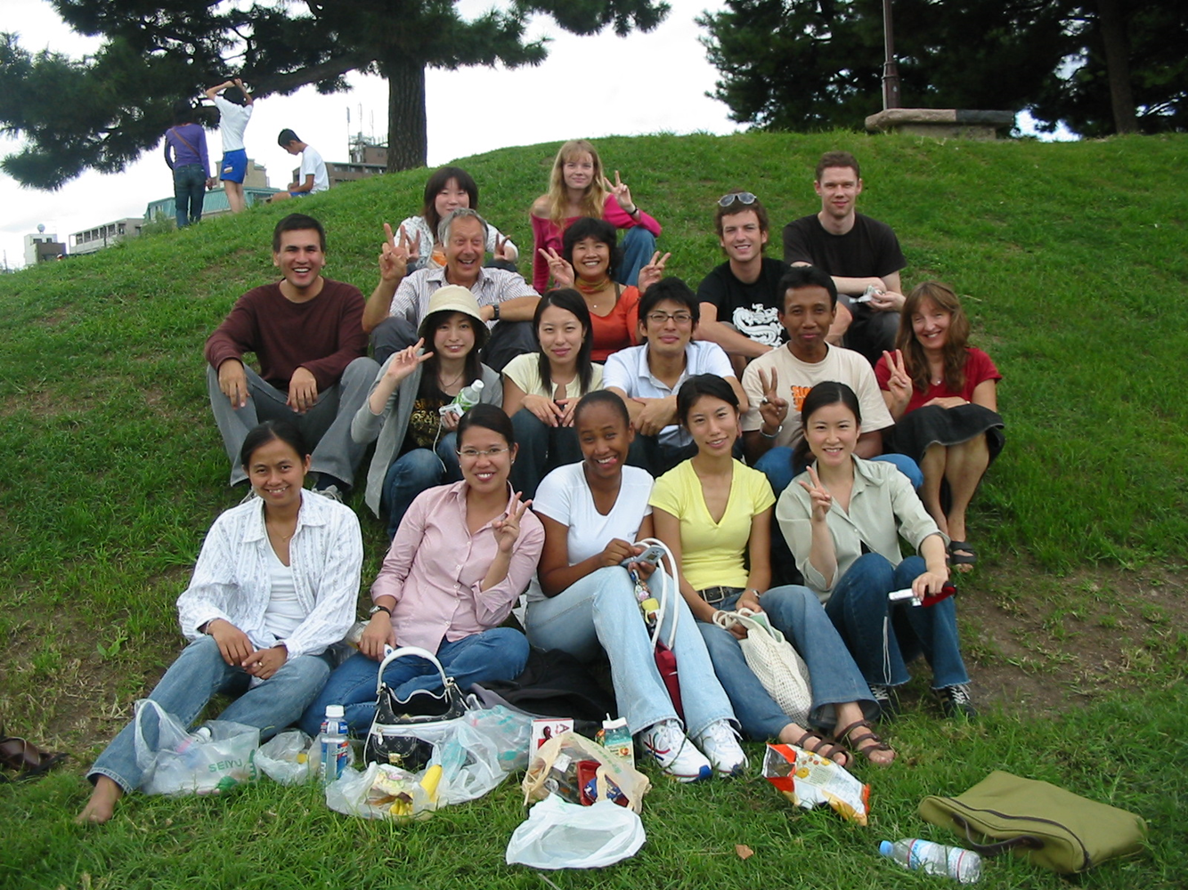

An international group of students picnicking in the grounds of a university in Japan, having prepared and eaten experimental foods – on which they will later be examined. Fun, bonding, stirs the blood, memorable.

OUT OF THE CLASSROOM!

AN ON-CAMPUS STUDY VISIT



*The table here shows an extract of real energy and carbon data from 2013-14, recorded and collated by the Estates Dep at the University of Bath. It forms the basis for classwork and exam questions.*

Natural Science students are introduced to the basic architecture of the university’s energy systems. They see the mysterious underbelly. They see the boilers creating hot water for heating, the Combined Heat and Power plant, the heat store, the metering, the distribution systems, the central chimneys. They learn which pipes and cables carry what. They start to learn the meaning of the inspection covers, and acquire a capacity to ‘see’ the invisible skeins of the university’s underground metabolism.

Back in the classroom they work with the statistics. Real data. Gas, electricity, heat, inputs from solar electricity, rates, quantities. Energy ‘behaves’ well’. Daily, weekly, annual fluctuations. Supply at all times to match demand. The students calculate the components of the university’s carbon footprint: a microcosm of the nation, which is a microcosm of the world. How else would you do it?

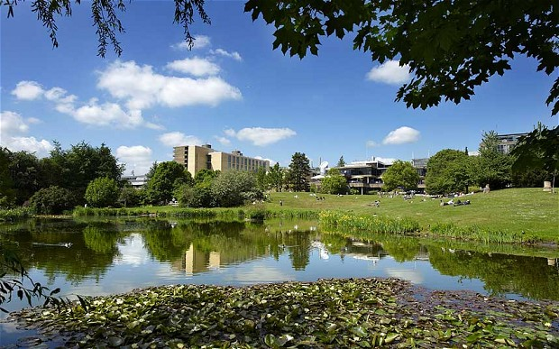

SHALLOW WATER WITH EMERGENT PLANTS: DRAGONFLIES ETC

INTERMITTENTLY-

FLOWING WATER

WOODLAND EDGE

NEST SITES FOR WATER-BIRDS

WILLOW: MANY ASSOCIATED SPECIES

OPEN GRASSLAND WITH SIMULATED GRAZING

WATER-LILY CLUSTER: FRACTAL UNDERSURFACE HABITAT

SIMULATED ROCKY OUTCROPS

BUILDINGS SIMULATING NUTRIENT-POOR ROCK SURFACES

OPEN DEEP WATER

TREES PROVIDING COVER

HUMANS GENERATING A LIGHT ‘RAIN’ OF NUTRIENTS

NUTRIENT-RICH MUDDY BOTTOM

MULTIPLE HABITATS EVERYWHERE.

University campuses can be extremely rich in habitat diversity. Obviously, this is most relevant to students in the life sciences, but biodiversity is a universal matter deserving greater appreciation not just a feature of nature reserves.

**POTENTIAL RESOURCES ON THE CAMPUS NOT WIDELY USED FOR TEACHING:**

* Data, statistics already collected for other purposes
* Physical infrastructure, buildings, service systems
* Knowledge and skills of Estates and admin staff
* Natural landscapes, habitats and populations
* The local climate and weather variations
* The university as an organism, institution, business
* Stocks and flows of energy, materials, water, food, goods, waste, people
* People in all aspects – physical, mental, cultural, individuals, groups, ethnicities

Material flows:

The University collects unwanted ICT items and sends them for re-use, refurbishment, remanufacture or materials recovery

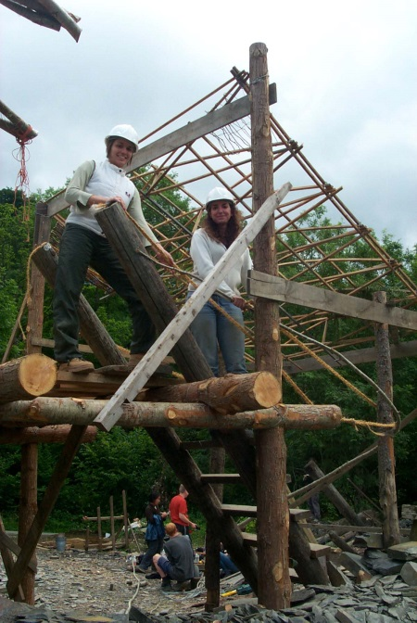THE “PLAYGROUND”

A space should be made available for open-ended experimentation. One approach, long used by students of architecture at the Graduate School of the Environment in Wales, is to present a practical (usually structural) problem that the students must solve collectively, using whatever resources are available on the site, of which there is a generous and diverse selection. They often create novel materials and composites.

The result is usually some kind of building, but *the process is more important than the result*.

We imagine that university students of architecture and engineering could collaboratively design and create a basic semi-permanent structure that would provide shelter for students in many other disciplines, but which could be extended, modified, replaced as requirements demanded. The structure should maximise the resources of the chosen site.

Architecture students in the ‘Playground’ at the Graduate School of the Environment

The playground could also accommodate all manner of other experimental structures.

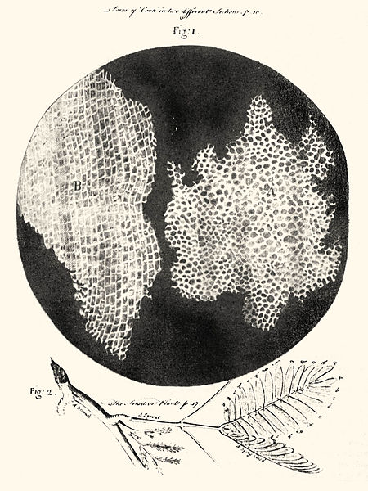RELIVING HISTORY

For obvious reasons students tend to learn a subject in its ‘state of the art’ form, but have little appreciation of how it all started, or the painstaking process of gaining true understanding. It can be very enlightening to explore the early history and foundations of a subject in a ‘ludic’ and even ludicrous, fashion. Very often this will go back to the 17th/18th centuries or even earlier, and it is all the better if the students are limited to the tools and materials of the time.

Profound and foolish questions can be asked and answers sought; there is endless scope for speculation and re-interpretation.

“Omnis cellula e cellula”.

Recapturing a eureka moment

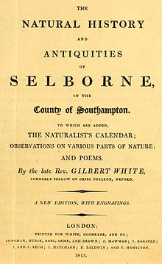

CLAVERTON DOWN

These kind of things could take place in the ‘playground’

* Extract copper from an ore sample
* Calculate the net productivity of a wood
* Collect 100 different organisms from a given area and create a classification system
* Create a shelter using only compression forces
* Write the first chapter of your own *Natural History of Selborne*.
* Make a compound microscope, draw ‘cells’ and draw conclusions
* Make a short movie combining the Law of Moments and circus skills
* Make hydrated lime from Bath stone
* Make fibre/lime composites and use them to create carbon-negative structures
* Prove that flowers are sex organs