FURTHER INFORMAL OBSERVATIONS OF BLACKFLY
Peter Harper, July 2021

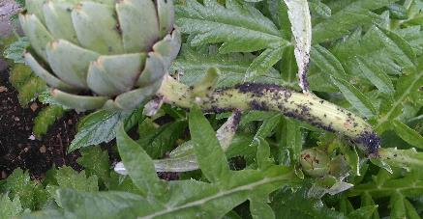
The first image shows a ‘healthy’ colony of blackfly (Aphis fabae group) on an artichoke stem (Cynara cardunculus var. scolymus).
Figure 1: Globe artichoke stem with healthy colony of blackfly, attended by ants. Note absence of ecdysomes.
In this image the aphids are grazing happily, attended by ants. I am surprised at the relative paucity of shed exoskeletons (ecdysomes), which should number several times that of the aphids themselves, since they appear to be at least a couple of instars up from new-born nymphs.

The impression is one of order, perhaps on account of the ants, who are removing honeydew, and perhaps ecdysomes. The ants are very busy checking over their ‘cattle’, although I have not yet seen one removing ecdysomes.
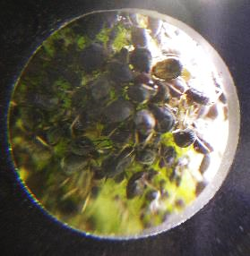
Figure 2: Close-up of part of blackfly colony on artichoke stem. Substantial crowding. Possible competition for feeding sites?
Second image shows a close-up, using a macro-device fitted to a phone camera. There is a lot of apparent crowding, and in fact on the field beans the stems were completely obscured by aphids. Looked like ‘bunches of grapes’. It is as if the aphids are not very picky about sites, as long as they can access the phloem stream of the plant.

Presumably they have to disengage from feeding when they moult, and might go off to a special ‘moulting place’ but again I could find very few ecdysomes anywhere.

Despite the crowding, the ‘early colony’ scene appears clean and orderly. The only ‘predation’ I noticed at this stage was from velvet mite larvae of the family Trombidiidae. These hang on, usually to the underside of an aphid, and presumably feed on haemolymph. Being bright red-orange, they are easy to see, but I noticed only a few.

Figure 3 shows a detached field-bean stem later in the cycle, following predation and parasitisation. There are also successive zooms, using the digital microscope camera.

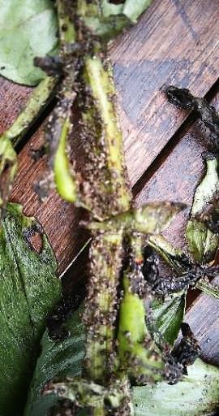
This is a complete contrast to the orderly healthy colony. There are still many ants, but the scene is one of utter devastation, irresistibly reminiscent of the aftermath of a battle. There are no living aphids at all. There are many plant lesions. There are many ecdysomes. The aphids have been killed in various ways, some by simple predation, probably by ladybirds and ladybird larvae, which appear fairly abundant. I have seen a few hoverfly pupae, suggesting that there must have been hoverfly larvae, also predatory.
Figure 3: Defunct colony on field bean stem, aftermath of a very heavy infestation by blackfly. Here they are all dead, but there were still ants patrolling.

A large proportion of aphids were killed by parasitoid wasps, indicated by the empty shells of swollen aphid ‘mummies’ with round holes, often with the ‘lid’ still attached or nearby. The lids are neatly round, suggesting a mechanical neural programme on the part of the adult wasps. Ideally, the cut has to meet up with its origin to enable the flap to come off, but the circularity demands another explanation. See Figures 5 and 6.

I have only observed the emergence of an adult from a mummy once, and I think it was because the emergent wasp got its wing stuck. It might be very quick, and preferentially executed at night when there is less chance of predation. It would be good to get a movie of the process.

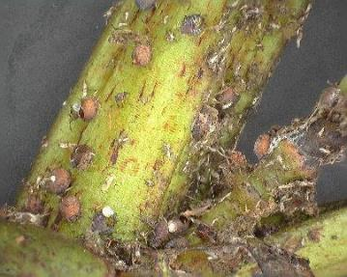
Many of the cadavers appear covered by a fungal fuzz. I don’t know whether there is a direct fungal attack, or whether this is secondary fungal growth on cadavers, presumably dripping with haemolymph and highly inviting to fungi. I would have expected other scavengers, but perhaps I have not yet looked closely enough.

Figure 4: Close-up of field bean stem shown in Figure 3. Mummies and ecdysomes are prominent.

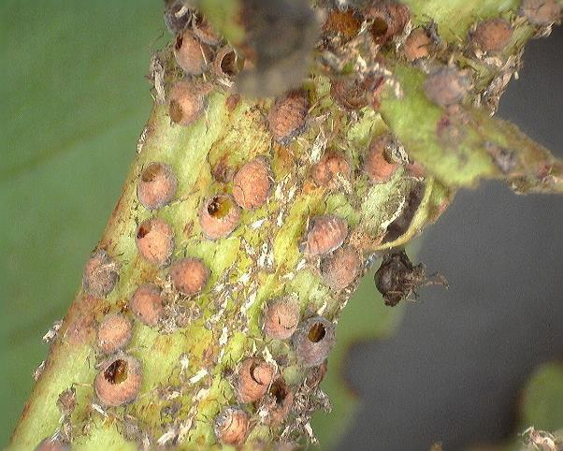
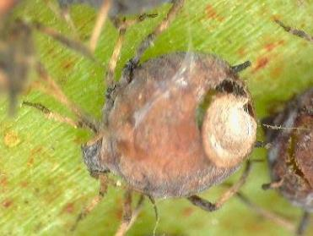
Figure 6: Close-up of mummy with 'lid'. The precise circularity of the lids, while obviously functional, needs explaining
Figure 5: Close-up of stem shown in Figure 4. Only mummies and ecdysomes are visible, suggesting that parasitism was the main cause of death for this part of the aphid colony. I cannot interpret the black object on the right. Possibly an aphid predated in another way.
The effect on fruit production is substantial, see Figure 7.
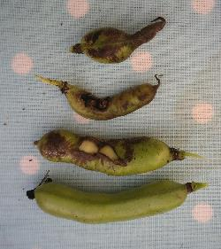
Figure 7: Pods from field beans: Bottom, a sound pod; others stunted and heavily grazed, with exposed seeds.
I found it striking that after the collapse of the aphid colony, some of bean plants put on fresh leaf growth and even fresh flowers, although the lower stems do not seem capable of supporting a new crop. See Figure 13.

SOME PROVISIONAL REMARKS

These observations raise all manner of questions. It seems that in the beginning the ants are well in control, harvesting honeydew, transferring to the nest and feeding the queen and larvae. My impression was that they attempt to shoo away predators, and in this case perhaps delayed the later phase by acting as effective ‘shepherds’. Evidently, they were unsuccessful in the end. We might speculate they were too small to deter ladybirds, and could not prevent the ladybirds laying eggs. Ladybird larvae are also too big to fend off. Perhaps the parasitoid wasps too, evade the ants by quickly injecting their eggs ‘while the ants aren’t looking’, or perhaps there are simply too many of them. Once a wasp is ‘on the case’ it is easy to inject one aphid after another as their abdomens stick out invitingly.

The lack of hoverfly or gall-midge larvae suggests that perhaps the ants were successful in preventing egg-laying by adult females, which can take a while, and the hoverflies are small enough to shoo away.

It is striking that there are still ladybirds and ants around the defunct colony. What are they doing? Adult ladybirds can easily fly away. Perhaps they still hope for a few more meals, or might be taking advantage of enhanced mating opportunities. Perhaps the ants are simply following pre-programmed behaviours, leaving the nest in search of food, climbing the plant, not finding much, then wandering about baffled by the turn of events, unable to ‘call it quits’ and look for other sources.

If it was the ants that ‘kept order’ and cleaned up earlier, they appear to have completely lost control, and no longer have a source of honeydew. But they might be shifting to another strategy: collecting other nutrients, notably protein from the cadavers and even chitin from the ecdysomes.

I will observe the subsequent development of the ‘battlefield’. Previous observation suggests the whole thing is mysteriously cleaned up, but hard to know who does it. Ants are prime suspects. It is conceivable they are adapted to a sugar-rich source of food early in the cycle, then switch to harvesting protein later. But they could be supplementing honeydew with chitin from ecdysomes all along. They might require help from fungi or bacteria to break down the chitin, just as leaf-cutter ants use fungi to break down cellulose.

Ants might be a key part of the cycle, although it is now clear they cannot ‘maintain control’ indefinitely. Perhaps they don’t need to. Although they have lost a source of honeydew, they might be taking advantage of predation to open up rich sources of protein.

From a gardener’s point of view, they might delay the action of predators long enough to make the difference between getting a crop and losing it, so action against ants my be part of a control strategy. In the present case, I experimented with diatomaceous earth, thought to irritate and deter many insect species, spread in continuous rings round ant/aphid communities on field-beans, globe artichokes and espalier apples. There appeared to be no effect whatever. I have also tried spraying the aphid colonies with ‘organic’ pesticides such as neem oil and horticultural soap, again with little observable effect.

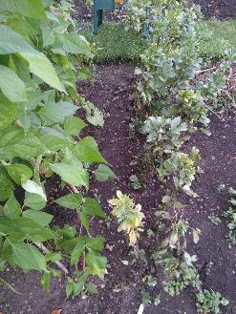
I have two ‘neighbours’ on the allotment where the field beans are, who have been growing broad beans, a larger-fruited variety of the same species. One lost the crop entirely, the other sprayed early and regularly with a home-made garlic extract, and has experienced very little aphid damage. This could be worth testing in future years. Possibly early garlic-extract treatment inhibited the growth of the aphid colony enough to prevent them getting established before the predators could become active.

Immediately adjacent to the field-beans is a stand of Borlotti beans. Almost every leaf has a few sporadic aphids, all dead from predation. This suggests that once the predator populations are established, they can quickly nip an aphid colony in the bud, but if the predators are not yet abundant enough, the aphids have a chance to develop very large colonies.
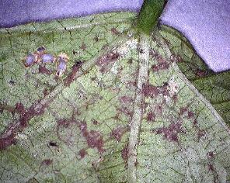
Figure 8: The row of field beans from which Figures 3-6 were drawn, showing the adjacent stand of Borlotti beans, supported on pyramids. The Borlotti leaves immediately adjacent to the field beans were lightly infested with aphids, all now dead.

Figure 9: General view of the underside of a Borlotti leaf adjacent to the field beans. The brown stains are single aphids or groups covered in fungal mould. Close-ups are shown in later figures, including the large winged form visible on the leaf rib upper left
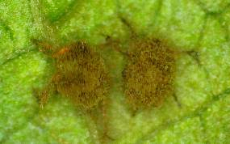
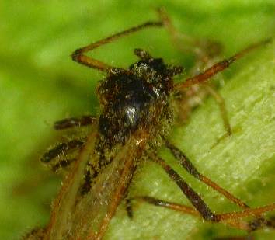
.

.

Figure 10: Two dead aphids showing vigorous mould growth

Figure 11: Winged aphid showing early signs of mould growth. This looks like mould growing from inside through the exoskeleton, not merely growing on the surface:
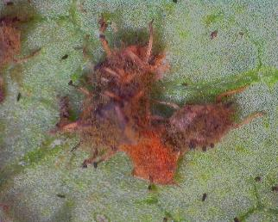

Figure 12: Group of dead aphids affected by moulds, including small black objects that might be organisms feeding on the mould. Or faecal pellets?

FOLLOW-UP LATE JULY

Although many of the field bean plants have died, most survive, and some are attempting fresh growth of leaves and even flowers, see Figure 13.

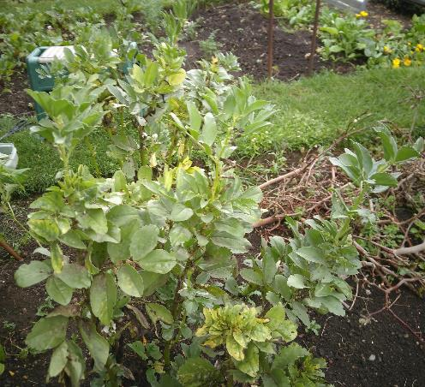
Figure 13: Fresh growth on field beans after blackfly colony collapse. There are fresh leaves and some flowers. Older, damaged and chlorotic leaves can also be seen
However, the older stems are still a mess. They have not been ‘cleaned up’, looking pretty much like Figure 3 several weeks later.
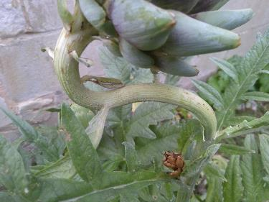
I took a still shot of the same artichoke stem shown in Figure 1. Here it is (Figure 14):

Strikingly, this stem is
now entirely clear, although there are a few visible lesions on the stem. Again, the question is inevitable: who clears up, and why?

And why are some colonies cleaned up, and not others?
Figure 14: Same artichoke stem as Figure 1, now entirely clear of aphids and associated predation debris.

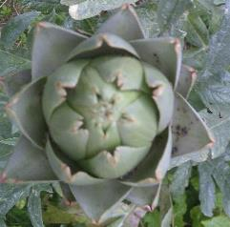
There are still live aphids within the flower sepals, and they are still attended by ants (Figure 15).
Figure 15: Artichoke flower photographed at some time as Figure 14, showing live blackfly inside sepal. No predators were observed.

One possible explanation is that the ants on the artichoke are still actively harvesting honeydew, and have to maintain rigorous hygiene standards that are not necessary on completely extinct colonies.

Perhaps they are removing corpses for hygiene, not for protein.

FURTHER OBSERVATIONS OF APHIDS AND PREDATORY LARVAE

‘How long it takes’ is an important consideration. According to the entomologist Stuart Reynolds, a parasitoid wasp can insert an egg within two minutes. I have observed a ladybird consume a small aphid in about the same time. In contrast, the predatory larvae seem to be slower, and might dispatch fewer aphids in a given time. This might have a bearing on which predators we encourage.

I observed a colony of (apparently) Aphis fabae on feverfew plants (Tanacetum parthenium), and detached a stem for closer observation and photography. There were several translucent-orange larvae about the size of a large aphid, which appear to have piercing and sucking mouthparts, not jaws. I do not know what species they are, but I suspect they are hoverfly larvae (Figure 16).
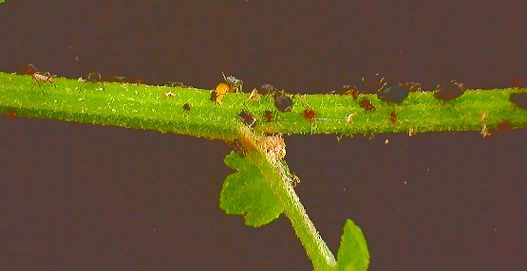

#

Figure 16: Feverfew stalk with a colony of various-sized aphids. Orange larva on top of stalk, left of centre

Figure 17 shows a closer view.
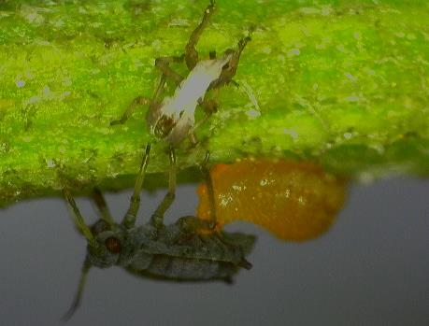
Figure 17: Larva attacking ventral area of a ??third-instar aphid, possibly not Aphis fabae. The whitish object above is an ecdysome.

Here the larva is attacking the ventral side of the aphid. I don’t know much about aphid ID but this does not look like A. fabae. Shortly after this shot the larva disengaged and attached the cephalo-thoracic region, Figure 18. Subsequent observations suggest this is common, and possibly unexpected.

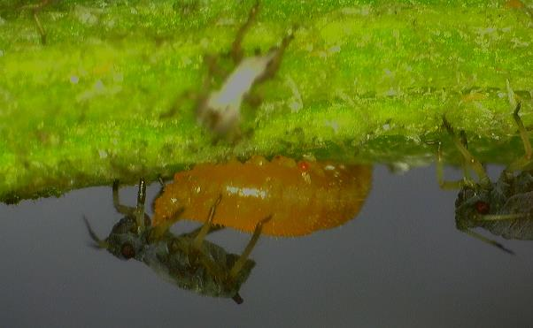
Figure 18: Larva attacking 'neck' of victim aphid. The red object on the larva might be an ectoparasitic trombidiid mite, sometimes seen on aphids themselves.

I do find it rather strange that the aphids seem unfraid of these predators. They do not attempt to escape. Various individuals continue to walk about, sometimes clambering over the predator as if to say ‘”Me next!”. Is it conceivable that some kind of group advantage accrues from predation? They are after all, clones, so there is no selection pressure to generate individual-survival avoidance behaviours. More thought needed.

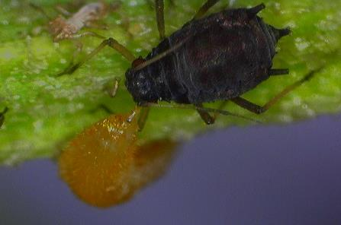
Shortly after these observations, I saw another larva attacking the cephalo-thoracic region of a larger aphid, almost certainly A. fabae this time (Figure 19). The engagement was quite short, about 10 seconds; then the larva disengaged and disappeared on the other side of the stem. The victim aphid was quite motionless. After about 5 minutes the larva reappeared and engaged the ventral abdominal region (Figure 20). Once hooked in, it did not appear to do anything. There was no heaving or signs of feeding. However, the outer limbs of the victim flexed in an apparently reflexive manner. I have a video-clip of this.
Figure 19: Larva engaging with head or possibly cephalothorax. The aphid did not attempt escape, but remained still.
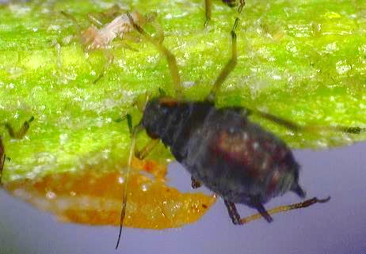
Figure 20: Larva engaging in abdominal region of victim

After about 30 minutes, the larva disengaged and attacked the nearby ‘neck’ region. After about five minutes it moved around and attacked the neck region on the other side. Such moving about suggests it is not feeding only on haemolymph; or perhaps there are partitioned haemolymph compartments that cannot all be accessed from any one place. I have a videoclip of the ‘head’ region of the larva waving about as if seeking the best engagement site.

This (July 30) might be the end of the season for all these processes. Most of the plants attacked are now clear of live aphids and predators, so it might be difficult to continue observations. Although of course this is itself an interesting and useful observation.

A FINAL REMARK
There are many ‘hares running’ here, many hypotheses that need addressing. It is interesting to consider whether simple observations in the manner of Gilbert White or Charles Darwin can resolve them. We do have some items of equipment not available to older naturalists.

FURTHER COMMENTS JUNE 2023
The usual blackfly infestation arrived on the globe artichoke, with attendant ants. We also noticed a large number of harlequin ladybird larvae, somehow getting everywhere, even though they cannot fly. I collected a few and put them on the artichoke. They seemed to be pretty hungry, and would typically sieze the first aphid they came across. Predictably the aphid would thrash about, and it appeared difficultrfor the larva to ‘let go’ in order to find a better site to bite through. More observations are needed.

On one occasion I noticed an ant attack a larva by (apparently) biting its head, whereupon the larva fell off the leaf. It could be that a succeesful bite (formic acid?) quickly incapacitates a victim.

I also noticed a small insect (parasitoid wasp?) with a short straight ovipositor backing up to aphids and presumably injecting eggs. It was much smaller than the ants, and appeared to be avoiding them by running off when they were near, then going back when the coast was clear. It did not fly away.

