GRADUATE SCHOOL OF THE ENVIRONMENT
SUSTAINABLE FOOD AND NATURAL RESOURCES
JANUARY MODULE

SPREADSHEET EXERCISES FOR DISTANCE LEARNING STUDENTS
Peter Harper

As part of the Zero-Carbon Britain project, I prepared two spreadsheets representing the UK food system. One of them dealt with basic food commodities emerging from farms and bulk imports, the other with foods as purchased at the retail level, mostly from supermarkets.

We can use these spreadsheets to examine the properties of various food groups, and to vary the quantities produced or consumed to simulate alternative possibilities. This allows us to create a wide range of possible ‘alternative futures’, some of which might be better than today, but all based on robust data.

You will receive the spreadsheets electronically as Microsoft Excel files. You should save and label one master copy of each and leave them unamended so you can go back to the originals if necessary. For any further trials, make a new copy, relabel and save. If you create complete new scenarios, be sure to label and save as a separate file (and keep them in a special folder). It is always helpful to explain your workings to yourself as you go along: because you’ll forget later what you did! It is usually best to open a separate tab for your notes.

A handy tip if you are not used to spreadsheets is that you can see more of the sheet if you hide the ribbons or use full screen mode while you are working.

COMMODITIES

OK, let’s start with the Commodities sheet. There are two versions of this, so pick the one called PRESENT Land-Use Modelling Spreadsheet SF&NR for DL. When you open it, you will see it has three tabs: LAND USE, NOTES and TABLES AND GRAPHS. LAND USE is the main sheet you will work with. It looks frighteningly complicated but it’s mostly just adding things up and you’ll soon learn to find your way around. NOTES contains a record of why what is where and what I have done, including references. Have a quick look. You will find it helpful to open another Notes Tab of your own to record what changes you have made. TABLES AND GRAPHS is a mucking-about sandpit where I play with data I have extracted from the main spreadsheet, and make graphical representations. It looks like a chaotic mess, and in many ways it is. I just use it to try things out and if they look promising I make copies and explore them further in new spreadsheets. I have left it in as an example of a spreadsheet sandpit. You could do the same, although it would be advisable to be more systematic and label all your explorations. You can have as many new tabs as you like.

(You will see that in the LAND USE page I have also used Rows 49 onwards, below the main spreadsheet, as another sandpit to test out further derived statistics and simple graphics, with the numbers easily copied and pasted right there and then. For example, I might want to compare the tonnage of crop and livestock commodities produced in the UK or overseas, and generate a simple graph. On the right is a graph I got from this question, and it sharply demonstrates both the contrasting tonnages and the much larger proportion of imported crop products. You can of course ignore all this messing about, and if you find it a distraction, simply delete it).

Now, open the LAND USE tab if you have not already. You will see that the columns are numbered along Row 8, in addition to their standard spreadsheet letters, but it will probably be easier to use the letters, because they are always visible when you scroll down. In column A is a list of the main agricultural commodities. By this we mean relatively unprocessed farm products that we usually cannot eat directly. There might be some processing on the farm, such as threshing and drying, but essentially the raw commodities appear ‘at the farm gate’ and enter the UK Food system. Usually their first stop is something called the Regional Distribution Centre or RDC, and sometimes this is used as the dividing line between ‘production’ and ‘processing’, or between ‘agriculture’ and ‘the food industry’. So you will sometimes find references to ‘pre- (and post-) farm gate’ and sometimes to ‘pre- (and post-) RDC’.

Just to give an idea of the difference the Farm Gate makes, agriculture contributes only 0.5% of the UK’s GDP, while the Food Sector as a whole is about 10%. In energy terms, agriculture uses around 1%, while the food industry uses over 15%. In some respects, the action is all after the farm gate. Nevertheless, in terms of greenhouse gas emissions (GHGE), land use and ecosystem services, agriculture is the dominant player, and that’s why production of food commodities is so important.

We need to say something about imports, because the UK produces only about half its own food, and in fact we spend more on imports than on our own production. Of course, we export too, but much less than we import. In the spreadsheets, imported goods are grouped together so they can be identified and (in some cases) treated differently. There is a small complication in that some imported foods are already highly processed and bypass the RDC and the processing system (and go straight to the deli) but the spreadsheet ignores this and lumps them all in as commodities.

It is important to say that the data inputs are getting rather old, since there has been no opportunity to update them. This is particularly true for food imports, which have grown substantially in the last ten years. Nevertheless the bare bones of the UK’s food commodity inputs remain broadly correct and the spreadsheets are accurate enough for the kind of modelling of alternatives we wish to pursue.

Look again at Column A. What we have done is to divide the commodities into two large groups: Crop Products at the top, and Livestock Products at the bottom. The reason for this is that any study of this topic will quickly reveal that to a very great extent livestock, and livestock products, have markedly different properties, including environmental impacts. From the perspective of ecological energetics this is only to be expected, but it is surprising how unusual it is to analyse the food and agriculture system in this way, deliberately contrasting crops and livestock.

Have a look at the various factors considered in Row 10. The units used are in Row 9. Some of the numbers are simply statistics taken from published sources, for which the references are in the NOTES. Others are derived statistics using simple formulae operating on the raw data. Click on any cell and you will see the difference: either a simple number or a formula. Note that most of the production data are ‘per year’. Production varies a lot from year to year, so generally we have taken generic averages of the kind that farmers use.

Now look at the totals in Rows 46, 47, 48. If you click on any of the ‘total’ cells you can see from the formula (in the formula bar at the top) that these are just adding up. Note that you can meaningfully add up simple numbers, but you cannot add up ratios, so not all cells in these rows have entries. Row 46 shows values for crop products, Row 47 values for livestock products, and Row 48 the totals for both. The blueish cells in Columns B to F show absolute quantities of commodities in thousands of tonnes a year (kt/y) as measured at the farm gate – although of course they are not usually actually measured there but later in the chain, typically a weighbridge at the RDC. Columns I, J and K show greenhouse gas emissions (GHGE) as CO₂e, again in kt/y, and it is worth noting the contrast between the crop and livestock values. The red cell K48 shows the whole annual GHG emissions from the commodity sector, including imports (which are not included in official UK statistics for emissions: ‘not our problem, John’). Columns L, M, N, O show the land used in the production of commodity groups both in UK and overseas. The grey cells show the annual totals. Further along Row 48 in Columns W and X are values for total calories and protein in the commodity stream. These are considerably higher than strict nutritional requirements, but of course there are substantial losses through the rest of the food chain.

For any of these measurements, it is worth comparing the actual figures for crop and livestock products in Rows 46 and 47. The differences are often surprising if you are new to this field.

That should have completed your survey of the spreadsheet as constructed in 2013, using somewhat data available at the time. You are now ready to model Alternative Britains!

MODELLING

Scroll along to Column Z. It is highlighted green, and your default version has the number 1 in each cell. This means that the proportions of commodities are the same as those established when the spreadsheet was constructed in 2013, with the same totals (small differences are due to rounding errors and approximations in the formulae). This is the ‘baseline’. You can create differences by entering other values instead of 1 in column Z. For example 0.5 will model the result if only half of that commodity were produced. 3 would model production three times greater than the baseline. And so on. Row 8 at the top shows the overall results of your changes, in the following Columns:
AD (dark green) shows the total quantity of food in kt/y
AF (red) shows the total emissions in CO2e/y
AG shows the energy value in kcal per head and day
AH shows the protein value in g per head and day
AI shows the arable land required in the UK
AJ shows the arable land required overseas
AK shows the total area of grazing land required
AL (puce) shows the area that could be available for other purposes such as biomass crops

Of course, in the spreadsheet you can do anything you like, but many of your results would not be viable in reality. To prevent ‘cheating’ you must satisfy the following realistic conditions:
The total quantity of food must be greater than 60,000 kt/y
The energy must be above 3000 (kcals/h.day)
The protein must be above 70 (g/h.day)
The arable area in the UK must not exceed 6500 kha
The arable area overseas must not exceed 2500 kha

There are two versions of the spreadsheet, labelled PRESENT and ZCB. You can use these for modelling under different assumptions.

EXERCISE 1
In the PRESENT version, everything is as it is today, with existing emission intensities. Remember to make a new copy for modelling. Change the various values in column Z. Can you find a combination of commodities that reduce emissions to below 40 MtCO2e/y, while meeting the other requirements? Note other ‘incidental’ results in terms of food produced and land released. Is there more, or less, than today’s figures? Comment on the political implications of your choices.

EXERCISE 2
In the spreadsheet called ZCB Land-Use Modelling Spreadsheet SF&NR for DL, a number of special assumptions have been made, details of which can be found in Zero-Carbon-Britain 2030. Here are some of the assumptions:
- The population is 71.4 million
- The energy system has been fully decarbonised
- Carbon intensities of traded commodities have been harmonised with UK intensities
- Some plausible technical advances have been made.

Again, remember to make a new copy. Change the relative values in column Z. Choose one of the following options, while maintaining the other requirements:
- Imagine the UK has to become a net food exporter. How much can you increase food production while keeping emissions below 30 MtCO2e/y? Can you get over 90 Mt/y?
- How low can you get the overall agricultural GHGE? Can you get below 20 Mt/y?
- How much land can you release for other purposes? Can you get above 12 Mha?

If you are interested, you can try out the effect of the values used in the ZCB2030 report. These are in column Y and if you want to see the effect of applying these values, click on Z11 and type =Y11. Then stream the calculations down the Z column using the little black square in the bottom right of the selected cell.

DIETS

The spreadsheet titled Dietary Modelling for DL students is much simpler than the commodities one, but there are more categories of foods. If you open up the file and go to the tab marked CALCS, Column B contains a list of the kinds of foods you can buy in a supermarket. Although some of them are the same as those you encountered on the Commodities spreadsheets, they have nearly all been through the RDC-Factory-Wholesale-Retail process to end up in your trolley. Some need further preparation, but many are ready to eat.

To a great extent, the proportions of these foods that you buy define your diet. Actual diets are about what’s on the plate, but the number of possible dishes is too large, mixed up and complicated for us to use the Plate as a basis for evaluating diets. That’s why we use supermarket categories of foods, for which we can get reasonable data.

The list of food types in column B is broken into five groups, and nutritionists often say it’s important to have them all represented in any diet. These are the groups:
- Starchy foods: bread, pasta, grains, flours, potatoes
- Fruit and Vegetables
- Dairy and eggs, including non-dairy ‘milks’
- Meat, including meat substitutes
- Rich foods: sugary, salty and fatty foods, including oils

Some comment is called for regarding these groups. Simple survival needs energy, protein, fats, minerals and vitamins. In principle you could get all these from meat alone, but most of us prefer a more varied diet, and as we have already seen, livestock products tend to have high carbon and land intensities. So, for sustainability reasons we might wish to create adequate diets with lower levels of livestock products, or even none at all.

In reality, groups 1 and 5 have high energy; groups 3 and 4 have high protein; while group
2 is particularly rich in minerals, some vitamins and many other factors thought to promote good health and prevent certain diseases, hence the ‘five a day’ recommendation for fruit and vegetables. So actually, we could probably analyse diets in terms of just three food groups, but we’ll stick with the standard five, as found in the semi-official Eatwell Plate.

As it happens, the proportions of the different food groups out of 100 are commonly represented in a Pie Chart, and this can also be thought of as proportions on a traditional round plate. We can use pie charts to quickly summarise the various modelled diets. For example, the current average diet is represented by the chart here.

It is interesting to note that during the January 2018 module we carried out an exercise comparing the allocation of supermarket shelf space estimated by students walking around a local supermarket in their minds; with real measurements. The two tallied up very closely, and the results are shown in this pie-chart:
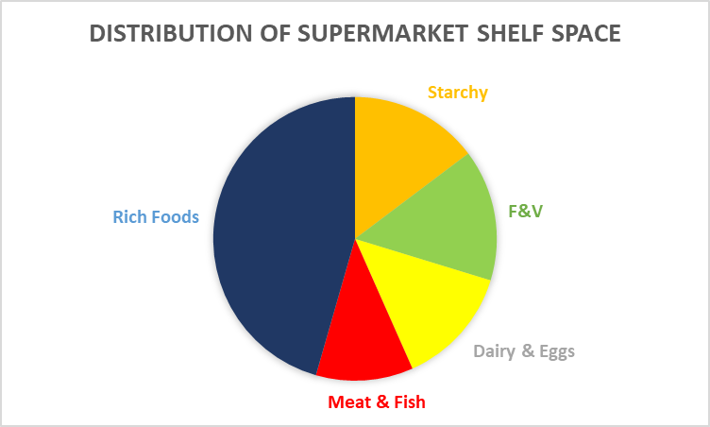
The so-called ‘rich foods’ are largely the ‘ultra-processed’ foods thought to be deleterious to health. But they are highly profitable – hence, presumably, the extra allocation of shelf-space relative to the actual proportion consumed.

Look at Column C in the spreadsheet. This lists the average amounts in grams consumed per day of each food category, as determined by the national Nutrition and Diets Survey. The total is in cell C80, and we take this as a basic datum for the amount consumed per day.

In cells B16, B28, B35, B56 and B74 you can see the subtotals for the main classes. Click on one and you will see it is simply the sum of all the numbers in the adjacent cells in Row C. On the PIE CHARTS tab, you can see how these subtotals are turned into a pie chart. If you are unfamiliar with charts, try this yourself. Select the whole block of words and numbers, which is already there, then click ‘Insert’ and then the pie icon in the charts box. Your pie will appear, complete with its ‘legend’, or key to the sectors in the chart. You can change the appearance of the chart by clicking on the chart and then clicking ‘Design’ in the ‘Chart Tools’ box. Notice there is also a SANDPIT tab with toys scattered everywhere.

Now let’s work through some of the other columns in the CALCS spreadsheet. Column D contains a number against each product type, some negative, some positive. This is a system of scoring the relative healthiness of each type, produced by the UK Food Standards Agency and called the Nutritional Profile or NP. In this system healthier foods have lower (even negative) scores. Next in Column E is a measure of the ‘carbon intensity’ of each product type, including on-farm production and all subsequent processing up to the supermarket till. Column G has energy values in kilocalories per kg of food as bought; Column H has protein content in g per kg of food.

You can probably see that multiplying a quantity of food in Column C with the various factors in Columns D, E, G and H will give a series of values for that quantity of food, and by varying the quantities we can simulate different diets with different properties. You can see how this works in columns J to M, where the values in the average UK diet are multiplied through. Click on any cell to see the simple formulae used, in the formula bar at the top.

These columns are then added up, with the totals in Row 80 for health, GHGE, energy and protein. Of course, we are mainly interested in diets which are both healthy and low-emitting, but they have to be viable in terms of both energy and protein, and that is why these two factors are included. When you are constructing your own experimental diets, you have to check that the daily total for energy is greater than 2500, and for protein is greater than 60.

EXERCISE 1

Make a fresh copy of the spreadsheet, and label it. Do a trial, using the highlighted columns O to S. For this we will imagine a person who eats a standard diet, but simply eats less, say 20% less than an average person. Although it is a ‘stereotypical’ diet it is quite plausible and there are probably many people with diets roughly like this. All we need to model this diet is to multiply the standard amounts by 0.8. So click on cell O11 and type “=C11*0.8”. Press enter and you will get a new number in O11. You will see other numbers appear in the cells to the right. Select all the cells from O11 to S11. Now grab the little square at the bottom right and run the numbers down the sheet. All the numbers will miraculously appear, including the totals in Row 80 and the group subtotals in Column N.

Have a look at these totals, and compare them with those for the standard diet.
 | Wt Consumed | NP score | GHGE | Energy | Protein
Average | 1750 | 2068 | 4158 | 4124 | 79
Eat Less | 1400 | 1655 | 3327 | 3299 | 63

Of course, the energy and protein scores are below the average, but still adequate, so this is a basically viable diet. And the health score is better (lower) and so are the GHGE. This already suggests that perhaps on average people eat more than they need, and would be healthier if they ate less. That is widely agreed by nutritionists.

EXERCISE 2

The previous exercise was rather mechanical. Now you will have to think a bit. What we want to do is to model a series of diets to explore both emissions and health. You do this by using Column O again, and changing the quantities in Column C. You just enter another number. For example, in Rows 9 and 10 we have bread. You might decide your modelled diet has more wholemeal bread than the average, so you could (say) reduce white bread from 67 to 20 and increase wholemeal bread from 16 to 70. And so on, working your way down the list. Some items you might feel are OK as they are. The totals at the bottom of the modelling columns will gradually change until you have finished. You can go back and tweak further as much as you like. If you make a mistake and accidentally delete formulae, you can always go back to the original spreadsheet and make a new copy.

In order to compare different diets on an equal basis, we need to keep some things the same. As a first approximation, despite what you did in the last exercise, keep the total amount of food consumed the same for all diets, that is our standard 1750 g. So you will probably need a bit of juggling within your new quantities in Column O to get this total. It does not need to be exact, as long as it’s between 1725 and 1775.

There are two ways to go about selecting your new values in column O. One is to take a diet you know already: your own perhaps, or someone you know. You might feel it does not fit the 1750 g yardstick, but it is the proportions that matter, not the quantity. The other way is to construct ‘stereotypical’ diets on the basis of rules, and that helps us discuss diets in general. Over the years we have created quite a range of these stereotypes, and students constantly invent new ones.

Here are some of the stereotypes. Choose one or two, follow the rules and see what you get, but remember the total quantity must equal 1750 g and protein must not go below 60. Use a fresh page for each, label and save, or if you are spreadsheet-savvy, create new column groups on the same page. In each case, you can use the subtotals in Column N to create a pie-chart of your modelled diet. You can paste the pie-charts at the top of your modelling columns, as a summary of the proportions.

The high meat and dairy diet. This one simply has a higher proportion of meat and dairy products relative to other components. You could make a new rule, say, increase every meat/dairy component by 10% and reduce other items accordingly.

The substitute lacto-vegetarian diet. This refers to the kinds of vegetarians who stop eating meat but substitute exactly the same quantity of dairy products and eggs.

The junk-food vegan diet. This refers to people who decide they will not consume any livestock products, but coming from a culture of high-energy and rich foods, they continue to eat even more of these to make up for the reduction of livestock products.

Typical vegan diet. This cuts out all livestock products and increases other elements to make up quantity and protein.

Transitional vegan diet. You can imagine a halfway stage between the last two. Must be quite common

The gorilla diet. This constructs a diet entirely of fruit and vegetables. Gets a good health score but not enough protein, so not a viable human diet. What would it need to just make it work?

The light-lacto diet. This reduces actual meat and substitutes with other protein sources up to an adequate protein intake, including dairy and eggs.

Flexitarian diet. This is basically low-livestock with occasional blowouts on high days and holidays, so samples all categories. Often associated with trying to optimise health.

Pescatarian diet. This is commonly associated with light-lacto vegetarians, but there are also dairy-free pescatarians. You might try modelling both kinds.

Paleo diet. This is supposed to mimic the ancient diets of our evolutionary past. Lean meat, nuts and seeds, fresh fruit and vegetables, fish, eggs and healthy oils. No carbohydrates!

Minimum-carbon diet. Some modellers have tried to find the lowest possible GHGE consistent with viability and dietary health.

EXERCISE 3 (OPTIONAL)
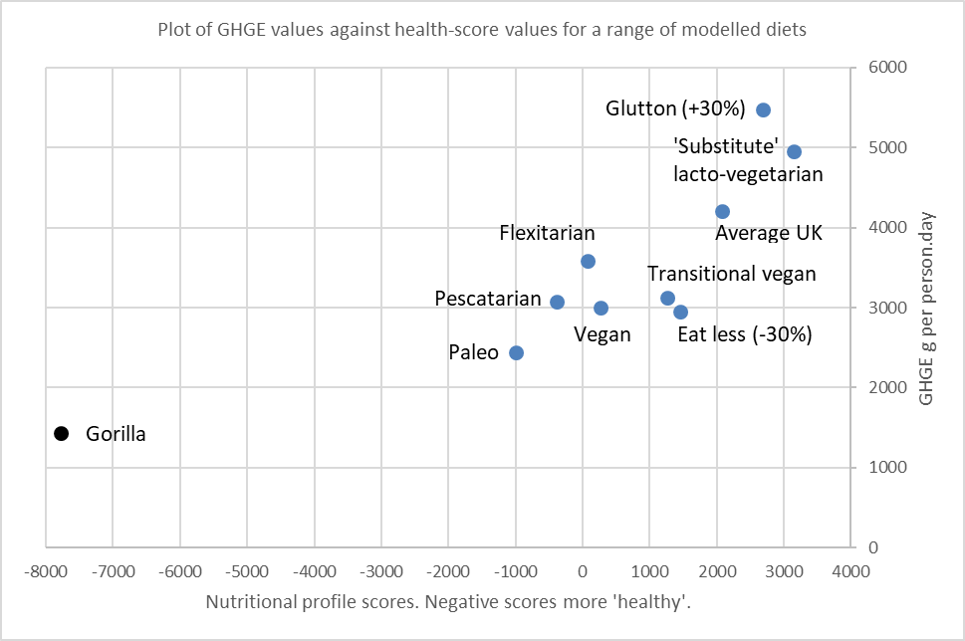
Only if you are complete fanatic. If you have modelled several of the above, and perhaps a few of your own, you could plot the results on an x,y chart using GHGE along one axis and health scores along the other. Here is a result we got in the class in January:

EXERCISE 4 (OPTIONAL)

If you have succeeded with the exercises so far, there are several possible variant approaches, and ‘improvements’. For example, one of the students observed that keeping the weights constant across the diets does not actually reflect equal levels of nutrition, since some foods contain more water than others. It might be more meaningful to use the energy score as the standard. Using 2500 Kcal/day as a yardstick and otherwise the same rules would generate different results and would be a useful exercise if anyone wants to do it!

Similar effects might be obtained from using ‘Dry Matter’ values, derived from the CoFIDS tables of McCance and Widdowson that you should all have. This would take some time, but would be pathbreaking work.

Good luck with all!

