THE TAN8 DEBATE CONTINUED

Discussion by Peter Harper on correspondence from
Mrs Elaine Williams
Mr. M. Richards
Mr. Christopher Penfold

3rd March 2012

The purpose of these papers is to discover what kind of ‘debate’ we are having, and whether constructive dialogue is possible. Probably there are several debates, with different protagonists bringing different values and preferences to the party.

The ‘wind farms debate’ often has a high temperature and is seen in terms of rhetorical battles with winners and losers. One gets the impression that the two sides are not mutually respectful, each imputing to their opponents venal motivations and ‘constructed’ beliefs. One might also guess that few are likely to change their minds, but if this is the case we have excellent material for a study of how ‘environmental’ opinions are formed.

Very helpfully two members of the audience at the original meeting in Newtown wrote letters expressing their views and criticising a form of argument used by myself in the opening speech. I asked these correspondents whether they would mind having their letters analysed and published, and they agreed. They will have an equal right to comment on, and criticise written materials by myself and others.

They will be invited to comment on, and annotate, these very words.

Although of course I do have views on the matter, and might be assumed to be partisan, my aim is to conduct the dialogue in as neutral a manner as possible. I assume that lapses from strict even-handedness will be immediately apparent to commentators and will be pointed out.

THE ORIGINAL ARGUMENT
I should summarise the argument I made at the meeting. I suggested that a good rule of thumb for evaluating different technological options vis a vis climate change, would be to consult the people of the future.

Of course they cannot actually be consulted, but we can imagine what they might think, and I have found this a helpful exercise for clarifying my own views. To make this process more personal and ‘human’, I imagined conversations with my great-great grand-daughter, living in the early part of the 22nd century.

At first, this procedure sounds eccentric, but it is based on what strike me as rational considerations. We can imagine what people in the future would prefer, simply by supposing them to be essentially like ourselves, with the difference that they are living out many of the consequences of ‘our’ decisions and activities. It works best for what we might call the medium term. People living in, say 2020, are essentially ourselves and of little interest in the present context. People living in, say, the year 3000 are too far away: they might actually be rather different from us and harder to ‘get inside’. The generations of the greatest interest are those in between: people very like us, who will have actual memories or vivid records of us.

This descendant group, three or four generations hence, will be living in the world now being created. They will, I suggest, have strong views about what the present generation did or did not do. They can be ‘asked’ about the implications of various choices. For example
- No serious action on greenhouse gases, possibly leading to a radically altered and uncontrollable climate
- Greenhouse gases reduced by a very vigorous expansion of nuclear energy, possibly leading to problems of weapons-proliferation and waste management
- Climate effects of greenhouse gases countered by a wide variety of ‘geo-engineering’ measures, possibly leading to unforeseeable side-effects.
- Ecological and other effects of energy technologies (such as dams, tidal barrages and biomass plantations), possibly leading to biodiversity losses
- Visual and other effects of energy technologies, possibly leading to altered landscapes

This philosophical device works because we can in some sense imagine ourselves in that situation, and would have views about what the present generation ‘should have done’. Of course we do not actually know what is going to happen, so these hypothetical ‘grand-children’ are in state somewhat similar to Schrodinger’s famous cat: not strictly anywhere, yet. But they obviously(?) would prefer to live in an orderly ‘modern’ world where the norms of civilised behaviour prevail, and not in a collapsed and chaotic world of failed states, eco-wars and unstoppable waves of refugees.

Here already is a point where the two sides tend to part company. Many, perhaps most, anti-wind campaigners do not think the ‘climate problem’ is as serious or urgent as some scientists believe. And if there is in some sense ‘no problem’ then the case for most renewables becomes far weaker, especially those as intrusive as wind farms. Let us agree on this.

However, it is important to set this question aside because it is in some respects a separate matter. We have to start this debate with the assumption that climate change is serious and requires the energy system to be largely decarbonised. Without this basic assumption we are not debating the same subject.

Let me start by copying a section of one of the letters I received, from Mrs Elaine Williams. This points out that wind farms are not carbon-neutral as they require a wide variety of carbon-intensive inputs:
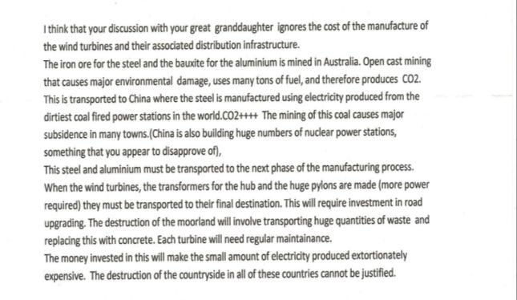
There are lots of points to discuss here. Mrs Williams assumes that the pro-wind ‘lobby’ really does ignore all these factors, and indeed might never have thought about it. From a technical point of view, these factors are all part of a Life-Cycle Assessment and as such, meat-and-drink to most energy analysts, who would be very surprised to be accused of not knowing about them. But this is simply a manifestation of the gulf of mutual disregard between the two sides: each regards the other as ill-informed, and/or wilfully neglectful of a range of relevant factors. What would count as a resolution?

An energy analyst would immediately try and put numbers into Mrs Williams’ list of steps: how much iron ore? How much aluminium? How much energy and CO2 emitted at each step? The manufacturing process, transport of many components, road upgrading, footings, concrete, maintenance, emissions from soil disturbance etc: all these would have to be assessed in such a way that they can be compared with various alternatives. Probably the best way would be to let Mrs Williams, perhaps with a bit of help if she wants it, work through some of the figures herself. A wind farm quite clearly starts with a large ‘carbon debt’. The question is how large, and how long might it take to be ‘paid off’ in terms of ‘carbon savings’ from ‘renewable electricity’.

The answer given by the wind industry is usually between 6 months and one year, but it would be very helpful for the overall debate if the basis of this calculation could be scrutinised in detail with those who have no stake in the finding the period rather short. Mrs Williams mentions the ‘small amount of electricity produced’, and again she would need to quantify this. Industry likes to talk it up; opponents like to talk it down. But with a reasonable amount of good will we ought to be able to arrive at a relatively narrow range of figures that we could agree on for the typical output of a turbine, or a whole wind-farm, and then look at the output over the whole year. The blades do go round; the generator windings rotate; electricity does flow through the substation meters and into the grid. Nobody can deny this: the question is how much? Are we being sold a pup?

The ‘official’ view on these matters is probably expressed by Lord Adair Turner, Chair of the Financial Services Agency, who has until recently served as Chair of the government’s Committee on Climate Change (see box).
"It is really regrettable that people leap – without reading the facts – to things that they want to believe," he said. "Wind works. The idea that it is so intermittent that it is not beneficial, that is rubbish. There are countries getting large amounts of energy from wind.
"If someone argues they passionately believe that windmills are bad for the aesthetic environment and are willing to do more nuclear instead, or willing to bear the cost of offshore wind, that is a real argument. But latching on to 'they don't work', or 'they are too intermittent' or 'they are not low-carbon because of the concrete' is just a failure to read the facts."
Lord Adair Turner, reported in The Guardian, 27 March 2012.

But wind-power sceptics are unlikely to find this entirely convincing without more detail. We would need to examine the widespread debate about the intermittency of wind and the need for backup plant. Wind is intermittent and it does need backing up with firm, dispatchable power. This is sometimes understood to mean that the backup power stations are running anyway and wind farms make a negligible contribution. This whole matter needs to be unpacked and re-examined from all sides.

I am not a power engineer myself but I know enough to be sure that wind farms do displace fossil fuels and therefore save carbon. I am happy to debate this should any doubt it. The question is how much? And how else could we ‘save carbon’ at a similar price? Here again Mrs Williams claims the electricity generated to be ‘extortionately expensive’, but we need to find some common basis for assessing costs, and comparing them with alternatives.

Cost considerations crop up a lot in the wind farm debates. It is widely assumed that prevailing energy prices are in some sense ‘natural’ as they based on availability of supplies, refining and generation costs etc., set by market forces. By historical standards fossil energy is extremely cheap. Is this to be accepted as a basic norm? It is commonly argued that fossil fuels are not ‘paying their way’ but getting large subsidies off the atmosphere and the various carbon sinks in ocean, soil etc. Other low-carbon sources seem expensive in comparison, and there are complaints about consumers having to subsidise them through energy bills.

Here is another set of hidden assumptions that divide the protagonists in the wind debate. Environmentalists tend to see energy as artificially cheap, while protestors see energy as too expensive, and made more so by government effort to decarbonise the economy. They feel they have a right to cheap energy. Where did this idea come from? How would we start to resolve this?

The final sentence in the extract from Mrs Williams’ letter refers to the ‘destruction of the countryside’, and here again we would need to be more explicit about the different kinds of damage, and the total damage caused, in order to compare it with the other alternatives open to us. Developers are required to carry out an extensive Environmental Impact Assessment, and it would probably be a good idea to invite antagonists to carry out a parallel exercise. It would be fairly straightforward to tot up the tonnage and volume of soil removed or disturbed. It is more difficult to assess the effect on local wildlife, and again the pro-wind side tends to dismiss the effects as negligible, while the anti-wind side suspects the worst, even if there is not a great deal of evidence. But let’s have the evidence. We would probably find that there are different conceptions of the meaning of ‘wildlife’ and we would witness strong effects of ‘motivated perception’.

The absolute key factor that eludes Environmental Impact Assessments is the visual impact of large structures where before there were none. This is remarkably hard to measure. To the academic mind this is a classic case of socially constructed aesthetics, but this is not how it is experienced.

Here is the final part of Mrs Williams’ letter:
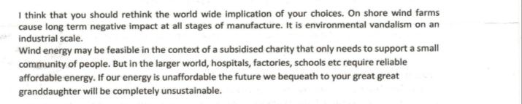

It is true that ‘On shore wind farms cause long term negative impact at all stages of manufacture’. So of course do all other energy systems. Would Mrs Williams accept that it is possible to work through the numbers (say in a spreadsheet) and arrive at reasonable comparisons? Or would this seem ridiculous? Would there be too many assumptions for the results to be relevant?

‘Environmental vandalism’ suggests visual intrusion as a key element. How can this be weighted against other ‘environmental’ values? Could economists perhaps help here?

Speaking of economists, Mrs Williams’ final point is commonly made within the Dismal Science: that if economic growth is maintained, people in the future will have a greater capacity to clean up any mess. Indeed, in this view the well-being of our descendants is critically dependent on economic efficiency today. There is an implied claim that wind-energy is so expensive that it will essentially cause the economy to collapse. Is this reasonable? Are there economic studies to support it? If not, could such a case be plausibly made?

The pro-wind argument relies partly on the opposite perspective: that people in the future will risk economic penalties and societal collapse if we maintain the status quo, and wind-power is part of a strategy to avoid this risk. That is essentially the conclusion from my ‘discussions’ with my ‘granddaughter’: that she would prefer visual intrusion to ‘climate chaos’ and its collateral effects. We have never put economic factors into the conversation, and perhaps we should.

THE TAN 8 DEBATE, CONTINUATION OF PH COMMENTS ON CORRESPONDENCE.

Second section

On 2nd November, Christopher Penfold circulated some comments on my remarks at the meeting, and in one case (Mr M. Richards) further handwritten comments were added, reproduced facsimile here:
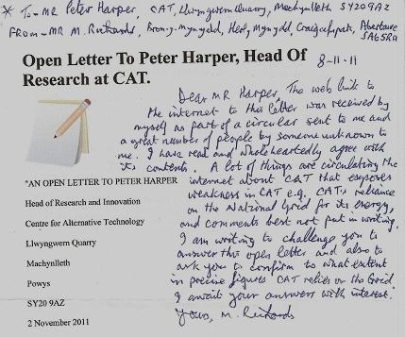

Mr Richards’ comment makes some specific points about CAT. There appear to be several implications here. One is that if CAT cannot ‘roll its own’ in terms of renewable electricity, then perhaps renewable energy (RE) as a whole is flawed and unworkable. Another is that CAT is hypocritical: it should not be telling others to do what it cannot do itself.

CAT certainly does derive most of its electricity from the National Grid. And an even larger quantity of energy is consumed in the form of bought-in gas for heating. So CAT is a very long way from providing its own energy needs. Is this hypocritical?

It is probably fair to say that CAT does not claim to provide its own energy; nor does it say this is necessarily a good thing. Nevertheless, in its early days it had no grid connection and was obliged to ‘roll its own’. A significant fraction of the electricity was produced by a generator running on imported butane gas, and later by diesel generators, but for most of the time this was less than half the total electricity consumed.

In my recollection there was a certain amount of pride in this supposed ‘self sufficiency’. Much of CAT’s early demonstrations and publications concerned ‘off grid’ power supplies, and it was known for promoting and indeed celebrating such practices.

A grid connection to part of the site was established in 1988, extending to the whole site by the late 90s. From time to time various new items of equipment (such as an externally-owned wind turbine selling its output to CAT) have temporarily changed the balance, but essentially the total amount, and the proportion, coming from the grid, has steadily increased since 1990. This has largely been due to increasing scale of operations.

If there was pride in ‘self-sufficiency’, logically there should be concomitant shame in its loss, and at the very low proportion of renewable energy in the mix. I think it is undeniable that CAT would ideally like to generate more of its own requirements, but has simply been unable to do so. In spite of many heroic experiments, the cost and technical difficulties have proved too great.

This is a telling point, and we have to acknowledge that it can be interpreted in several ways. Does it mean that RE as a whole is too expensive and technically complex to be a viable option? It would appear so at this scale, on this site, under these circumstances, and after all these years that is undoubtedly a disappointment . But it is a result, and the basic raison d’etre of CAT is to produce robust results based on experience and careful measurement, even if they go against its hopes and expectations. By its own rules, it is then obliged to adjust its beliefs, publications, and policy prescriptions.

Looked at in another light however, this ‘result’ points to a different conclusion: that effective RE usually needs to be pursued at a large scale, more centralised, with economies of scale, substantial investments, and high levels of specialised expertise. Although the ‘early CAT’ would have resisted this idea, and even now memories and ‘reputation’ live on and are hard to kill off, it has over the years become a completely different kind of organisation, recognising the need for major public infrastructure.

CAT has become principally an educational institution, with hundreds of students at all levels. Clearly it needs energy to maintain all these activities, and in many ways it is not surprising that rapidly growing demand has outstripped the capacity to extract ambient energy from the surroundings. Recognising this reality, and that of most other people living at high densities, CAT’s current policy is to encourage decarbonisation of the entire energy system, rather than pursue entirely local solutions, that have proved ineffective. This can be seen clearly in its recent report Zero Carbon Britain 2030.

So, to return to Mr Richards’ questions, the answer is yes, that CAT relies almost entirely on the grid just like everybody else, but accepts this as the genuinely sustainable way forward, and proposes ways to reduce the associated carbon emissions to near zero. Mr Richards assumes that if CAT cannot produce enough useful energy from on-site resources, this means it is impossible under any circumstances. This appears to be a weak assumption, but Mr Richards is invited to defend it.

Where Mr Richards might have a point is in this: that from a rhetorical or presentational perspective, it would ‘look good’ if CAT happened to be able to generate its own electricity on site. We might well accept this, but the extra costs of various kinds would seriously erode CAT’s core function as an educational institution. And in any case it would send the wrong message: that decarbonisation requires millions of small-scale production units. It doesn’t. Although such units can play a useful role, the heavy lifting has to be done by large installations of many different kinds, of which wind farms are but one example.

If not wind-farms, then other kinds of generating plant, each of which has its own drawbacks. Speaking personally I have been drawn to windfarms as the least-worst option from the perspective of our descendants, but of course wind cannot do everything. The purpose of these discussions is perhaps to clarify how much, and where, the different kinds of energy technologies impose their burdens.

THE TAN 8 DEBATE DISCUSSION OF CORRESPONDENCE

Third Section

Christopher Penfold wrote an ‘open letter’ that was widely circulated. It begins as follows:
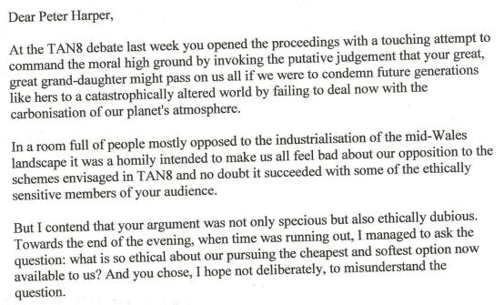
I regard Mr Penfold’s first paragraph as a fair summary of my presentation. Words like ‘touching’ and ‘homily’ however, suggest he felt the argument to be rhetorical rather than logical. I must confess to being slightly sensitive about this, because I try hard to create arguments that are persuasive by their logic or common sense, rather than because they press buttons or tug at heartstrings! But obviously I failed here, and Mr Penfold supposed I was using an illegitimate emotional framework. Something to think about.

With respect to the last paragraph, unfortunately I cannot remember this question, nor what my answer was, but Mr Penfold obviously regards this as a significant matter. Even now I cannot understand his point. I would have thought that cheapness was rather an asset than a liability, and indeed other critics, Mrs Williams among them, criticise wind power as being too expensive and potentially damaging our descendants’ patrimony. What would be required to decide whether wind-power in our local sense is cheap or expensive? What yardsticks would we use?

It strikes me as likely that, not just the overall cost, but the pattern of costs of various energy technologies influences our several views. Nuclear and renewables share a very high up-front capital cost, followed by relatively low running costs. Fossil fuels have the opposite quality, cheap to set up, but with continuing fuel costs. Fossil fuels remain overall cheapest, but (critics would say) that is only because they do not pay the full cost of cleaning up their waste products. For both reasons, people who tend to favour the interests of the present generation over future generations would rationally prefer to stick with fossil fuels; it would the other way round for people putting a higher value on the (supposed) interests of the future.

I think probably at the time of the debate I would not have understood the implied connection between present cost and ethical obligations to the future; and indeed I still do not, so this requires further clarification.

The next section from Mr Penfold’s open letter is as follows:
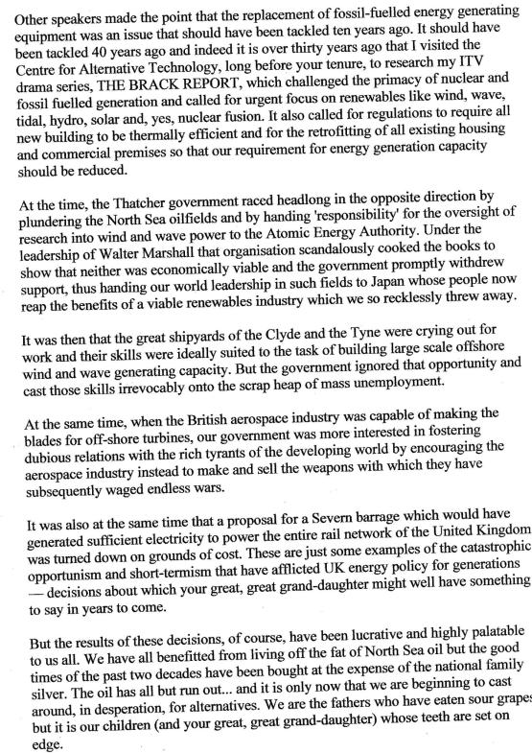
This strikes me as unusual from an anti-wind protestor, because it echoes the kind of views usually found in the pro-wind camp: that North Sea oil and gas were irresistible, but the opportunity to use the investment to fund their replacement was not taken. I seem to recall that when Tony Benn was minister of energy in the Wilson government around 1975, he proposed exactly this, that the profits and taxes should not be spent, but put into a fund to replace the stuff when it was used up. We know what actually happened. And we also know that many other opportunities were lost at the same time – to develop the overall renewables sector, expertise, jobs, exports – all of which by now would have stood us in very good stead. And what a hero Benn would now be!

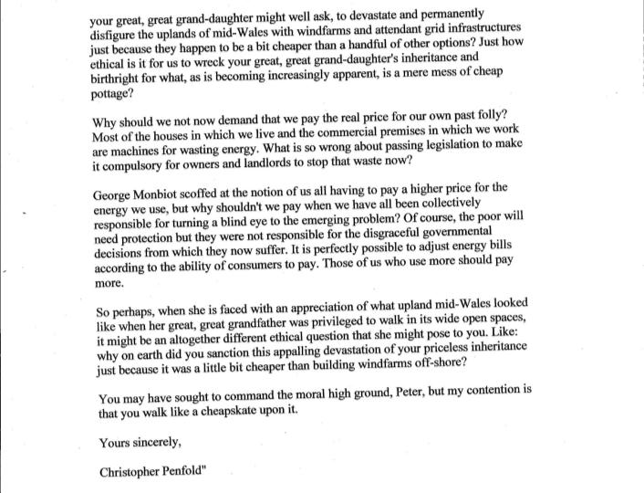
But we are not really surprised at this. We more or less expect each generation to grab what resources it can and leave the future to sort itself out as best it may. Mr Penfold however regrets this and in this respect he appears to be more sympathetic to my general argument about the rights (or at least interests) of future generations than I might have expected. Indeed he presses the point further:
Now this is really interesting and rather unusual. Mr Penfold appears to be anti-fossil fuels, anti-nuclear, pro efficiency and pro all renewables except onshore wind. And he accepts that we should pay the true, rather high, costs for energy. Rather like me in fact. What on earth are we arguing about?

Oddly enough—and I am happy to be contradicted by other people’s conversations with posterity—it is actually my great-great grand-daughter who has persuaded me. Her argument goes like this. If climate change really gets a grip, by (say) 2120 things could be really, really unpleasant in all manner of ways, and impossible to fix in any fundamental sense. The best that people could do would be constant adaptations to new and unexpected problems, with a fortress Europe, perhaps even fortress Britain, billions of desperate climate refugees, and continual ‘climate wars’. She really does not want to live in that world, and insists with the utmost vigour that she is not much bothered about what our generation does as long as it does not compel hers to live in that.

(For future reference, let’s call this the Worst Case World, (WCW). It is handy to give it a name because I believe in it, while it is widely disbelieved by climate sceptics and most anti-wind campaigners. Much of the debate, I suspect, will turn on this matter. Is it really likely to be as bad as some climate scientists say, and why should we believe them?).

But, I argue back, what about the unintended consequences of our efforts to prevent all that happening? Like what? she asks. Well, nuclear power stations, nuclear waste, you’d have to look after it, keep it safe, hand it on in good order. Even if you did not use nuclear power yourselves, you’d still have to keep looking after it. Her answer is this: OK, if you can find an utterly reliable way to avoid the WCW without nukes, then of course we would prefer that. But if there’s any doubt about the matter, dealing with nuclear waste is a thousand times better than the WCW.

Our concern with nuclear, she goes on, is not routine waste. That is really not a big deal in the scheme of things. The problem is what happens if your mitigation programme fails and we get the WCW anyway. The social and political instability of the WCW does not fit happily with a nuclear legacy and a kind of wild black market in fissile material. So (she says) avoid nukes if you can but don’t make a phobia out of it.

What if we could develop a new generation of nuclear reactors that are intrinsically safe and ‘eat their own waste’? Really? OK, bring ‘em on.

In spite of some reservations, she is far less anti-nuclear than I expected. Well how about the following query? If we install tidal barrages, large dams, biomass plantations, there will be quite unpredictable effects on habitats and biodiversity. Multiply that over the whole planet and it amounts to massive impacts that could bring about many extinctions. Her reply: of course we can’t say that’s good, but it will be as nothing beside the biodiversity effects of the WCW, so we’d say go ahead with all these decarbonisation schemes, but try to minimise biodiversity loss as you go.

Finally we get to wind power, and I press the ‘landscape’ argument on her. Surely you don’t want the land covered with large structures? At this point I have to tread carefully because she can get quite cross as if I think she must be stupid or something. She is absolutely emphatic that objects like wind generators are a completely trivial non-problem compared with the risks of the WCW. Her argument is that such structures are pretty well 100% reversible, even recyclable, and leave her generation with the maximum room to manoeuvre. If they want them they can keep them, if they don’t, they can take them down in, metaphorically, an afternoon.

Let’s ask her this: would it not be better to have the wind machines offshore? Then there’s no problem for anyone. OK she says, fine, if that’s what you want to do and it works, it’s all one to us. But why don’t you do it anyway? I have to tell her then that it’s all a matter of cost, and then she gets a bit puzzled. She lives in a world where what things look like is the least of their worries, and she can’t imagine any sane person pitting aesthetics against the WCW. So I have to tell her we really do have an issue with the appearance of landscapes.

And the conversation ends: Of all the major classes of energy technologies, her generation would prefer us to deploy renewables because they have the least long-term impacts and are pretty well completely reversible. She doesn’t care how we do it. If we want to pay more to avoid aesthetic impacts, fine, but (she sternly enjoins) not if there is the slightest increased risk of the WCW. On a bad day she thinks it’s immoral for us not to go for the quickest, cheapest options, because it’s likely to be a close-run thing. She is saying: wind farm aesthetics are a cost to you: don’t pretend they are a cost to us. The more you can shoulder the costs and not dump them into the future, the fairer it will be. Do not gamble with the outcome.

So to conclude this discussion in preparation for the next round of comments, Mr Penfold regards onshore wind-farms as a permanent desecration, while my great-great granddaughter regards them as by far the least worst option. I invite him to explain why she might be mistaken.

