PEOPLE’S TECHNOLOGY EXHIBITION 1972
MODERN ART MUSEUM ANNEX, SKEPPSHOLMEN, STOCKHOLM.

FÖR EN TEKNIK I FOLKETS TJÄNST
MODERNA MUSEET FILIALEN, SKEPPSHOLMEN

DOCUMENTS

- UNDATED PLANNING DOCUMENT IN SWEDISH (4 PAGES). Probably written by Björn Eriksson, representing the Pow-Wow Group, one of the ‘pop-up’ fringe youth-groups surrounding the UN Conference on the Human Environment, Stockholm, August 1972.

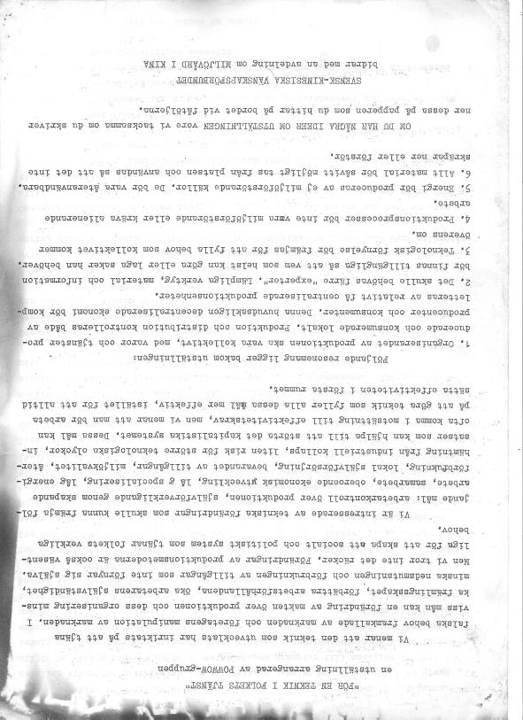

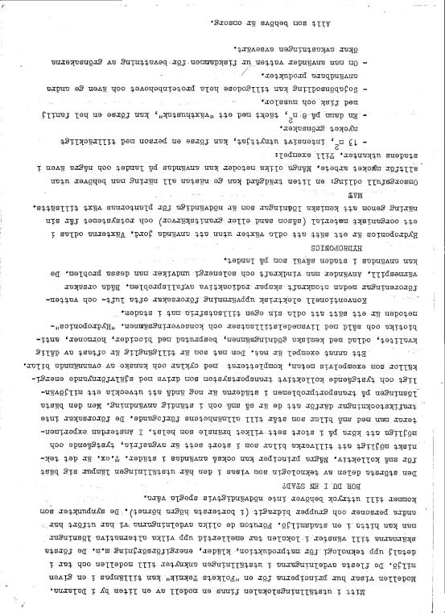

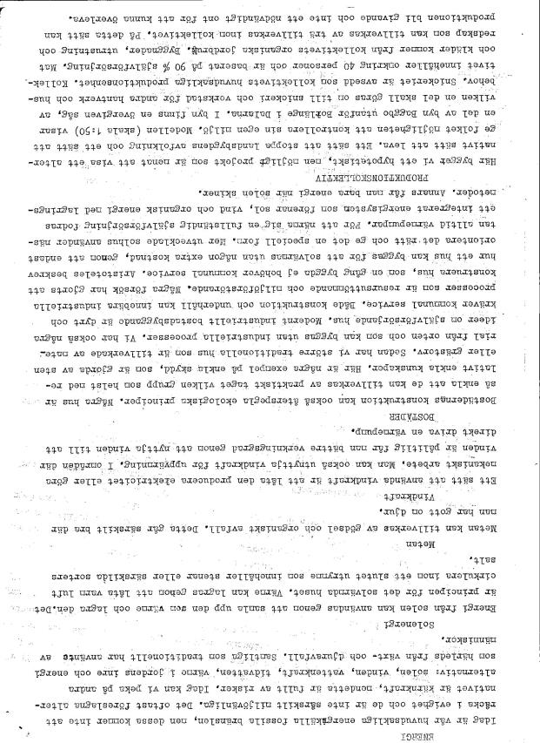

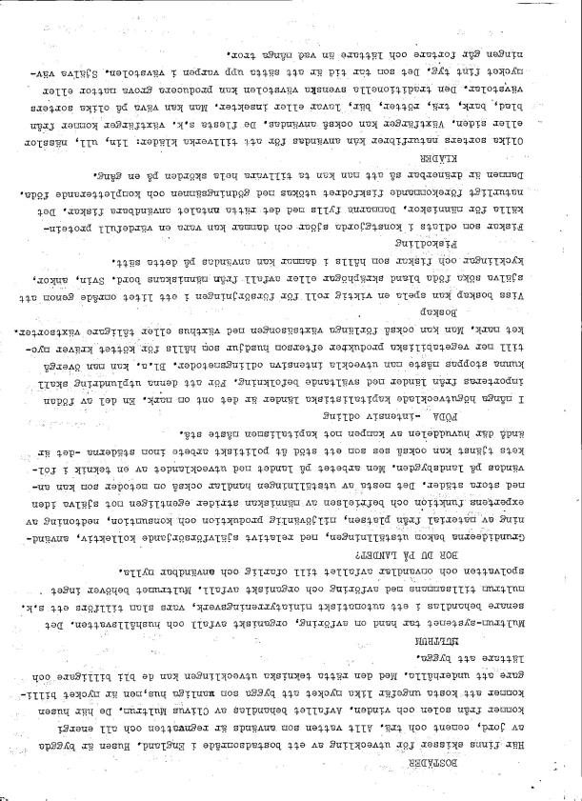

- A LAYOUT PLAN FOR THE PROPOSED EXHIBITION, IN ENGLISH, ATTACHED TO THE PREVIOUS DOCUMENT

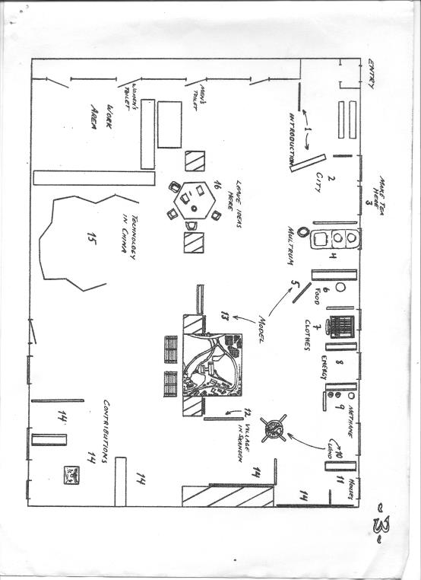

- A SHORT TEXT IN ENGLISH (2 PAGES)
Authors: Björn Eriksson and Peter Harper.
Since much of this material is reproduced in Document 1, probably the two are based on earlier material, now lost.

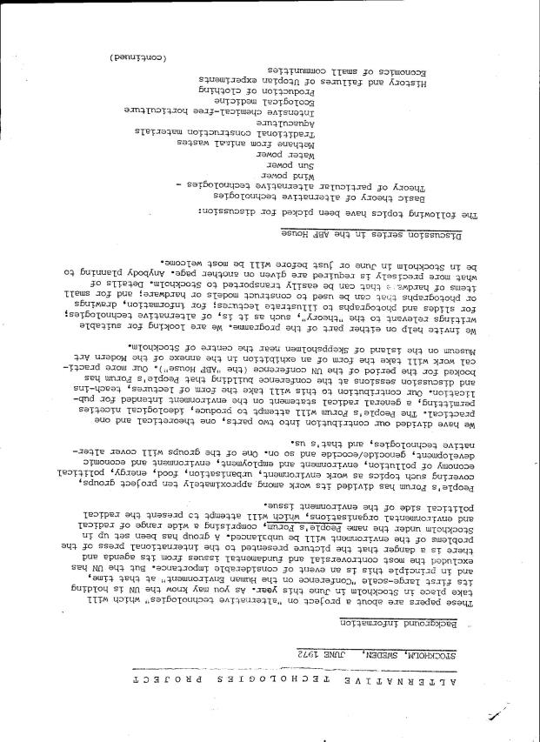

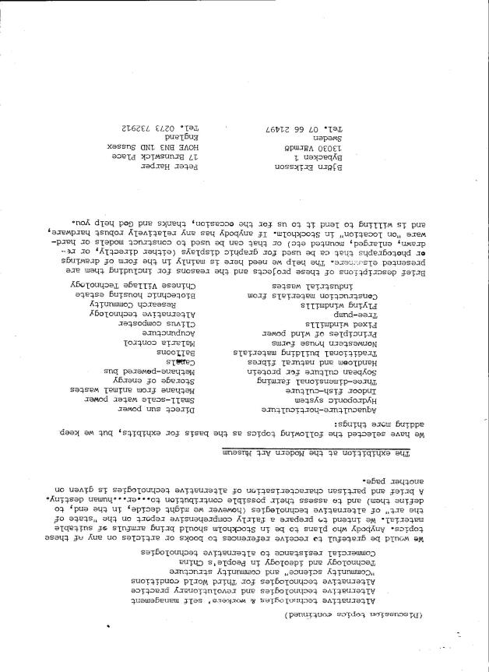

A MORE DETAILED PLAN OF THE EXHIBITS (5 PAGES)
Although unsigned or dated this is clearly written by Peter Harper. With further inputs from Björn Eriksson a developed version was eventually published in Undercurrents No 3 in 1973.

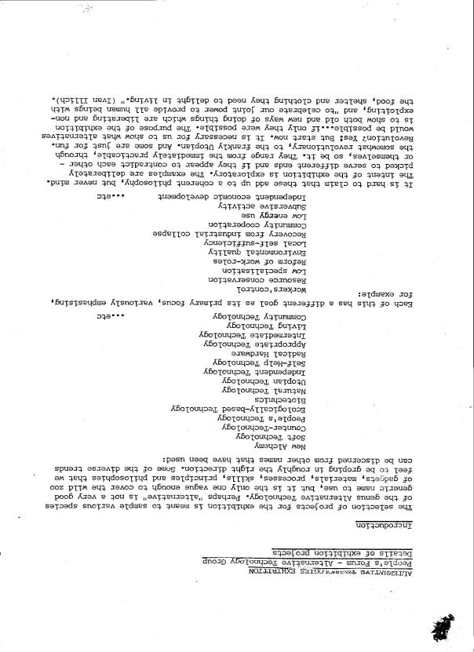
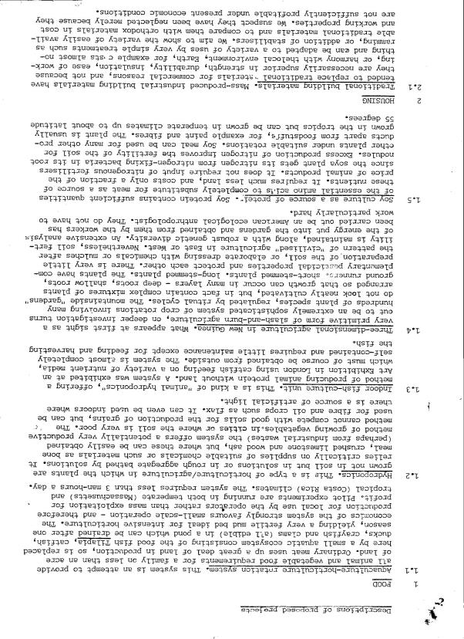

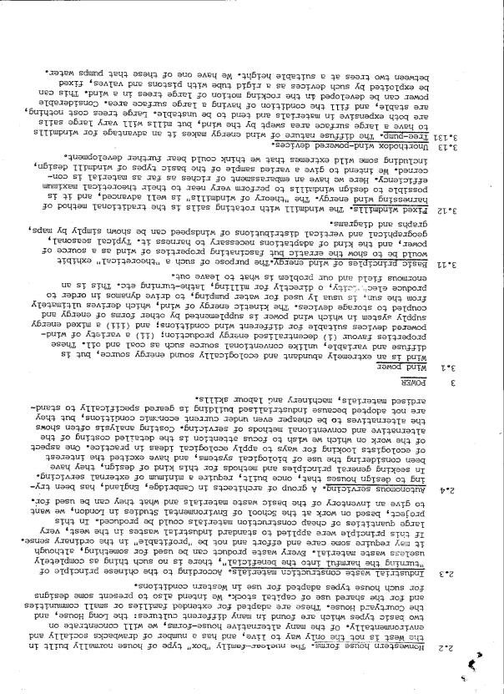

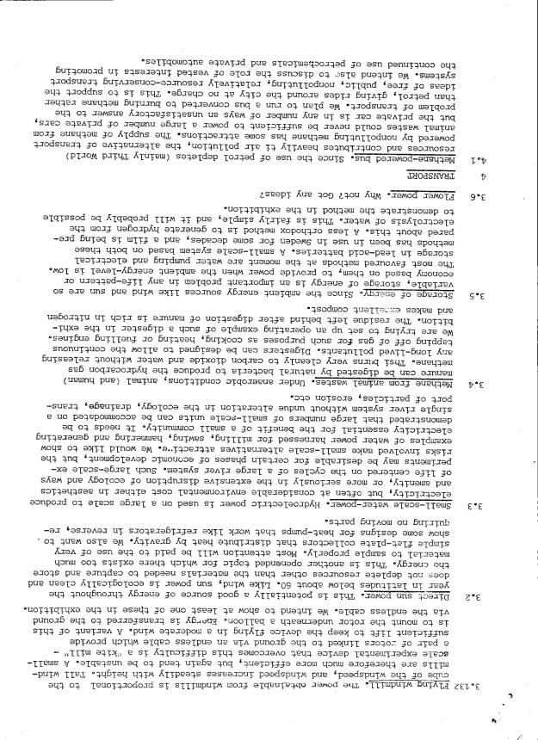

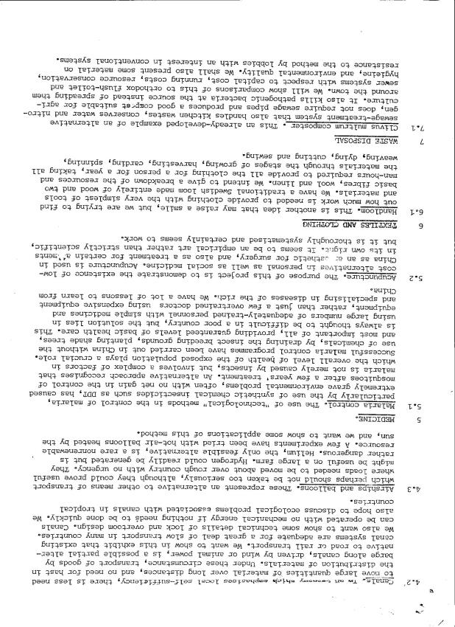

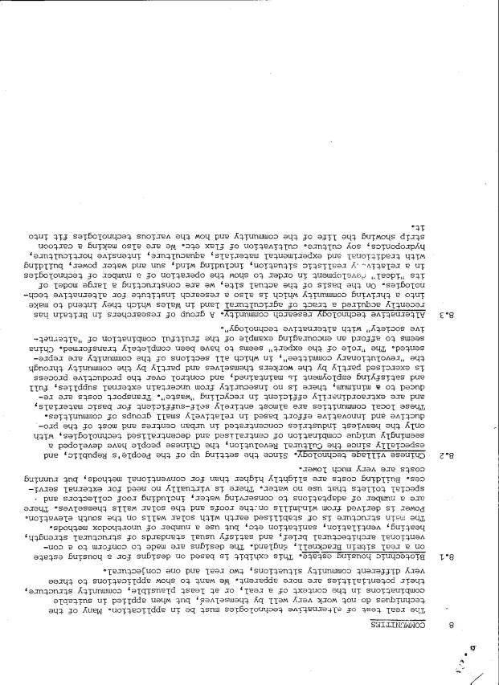

SAMPLES OF THE ANNOTATED BIBLIOGRAPHY AND GUIDE PUBLISHED IN UNDERCURRENTS NO 3 (1973)
This was probably the first published document using the term Alternative Technology, although the term had been in fairly widespread use since the eponymous conference at the Bartlett School of Architecture in February 1972.

It draws on the explanatory document for the Stockholm Exhibition, written by Peter Harper and Björn Eriksson.

The original document has too large a format to scan easily. This is one of the reasons why it does not appear in Chris Hutton-Squire’s heroic digitised collection of Undercurrents (http://undercurrents1972.wordpress.com/). Here I have merely scanned some samples to give the general idea.

It could be scanned more systematically if necessary.

This was the first of a series of annotated guides and bibliographies of AT, culminating in the very large bibliographic guide in Radical Technology (Wildwood House/Random, 1976).
